**ECS 15: Introduction to Computers**

**Midterm**

**November 6, 2013**

***Notes:***

1. The midterm is open book, open notes.
2. You have 50 minutes, no more: I will strictly enforce this.
3. The midterm is divided into 2 parts, and graded over 100 points
4. You can answer directly on these sheets (preferred), or on loose paper.
5. Please write your name at the top right of each page you turn in!
6. Please, check your work! If possible, show your work when multiple steps are involved.

**Part I (15 questions, each 4 points; total 60 points)**

(These questions are multiple choices; in each case, find the most **plausible** answer)

1. ***What is RAM?***
   1. An animal with horns,
   2. **Temporary memory space**,
   3. A video game,
   4. A device that stores energy for a computer.
2. ***How is it possible that both programs and data can be stored on a single disk?***
   1. Many disks have two sides, one for programs and one for data,
   2. It is not possible, as disks can only store data,
   3. **Programs and data are both software, and both can be stored on any memory device,**
   4. It is not possible, as a disk has to be formatted for one or for the other
3. ***Which of these is NOT software:***
   1. Microsoft Word
   2. Microsoft Powerpoint
   3. Grand Theft Auto V
   4. **DVD**
4. ***How much memory is one gigabyte?***
   1. About 1000 bytes
   2. **About one billion bytes**
   3. About one million bytes
   4. About 100,000 bytes
5. ***How much space would you need to store a 5 min song that has been sampled at 44.1 KHz, with each data point stored on 24 bits, in mono (i.e. with a single microphone)? Assume no compression.***
   1. About 40 GBytes
   2. **About 40 MBytes**
   3. About 4 Mbytes
   4. About 400 KBytes
6. ***Let X be the number with the hexadecimal representation AA and Y the number whose hexadecimal representation is 9D; which of these numbers T (in hexadecimal form) satisfies X-T=Y?*** 
   1. A
   2. B
   3. C
   4. **D**

*X=#AA= 170; Y = #9D = 157. Therefore T = X-Y = 13 = #D*

1. ***Which of these bytes represents the letter P (uppercase) based on the ASCII code?***
   1. 01010000
   2. 10100000
   3. 01010010
   4. 10100010

1. ***A new type of binary-encoded clock is introduced and work as described below:***

Add the values of each column to get six decimal digits. There are two columns each for hours, minutes and seconds.

***In the example shown:***

Hours: 1 in the left column

0 in the right column

Therefore: 10 hours

Minutes: 3 (1+2) in the left column

7 (1+2+4) in the right column

Therefore: 37 minutes

Seconds: 4 in the left column

9 (8+1) in the right column

Therefore: 49 seconds.



***What time is it on this clock?***

1. 17:59:31
2. 15:59:31
3. **17:59:21**
4. 17:49:21

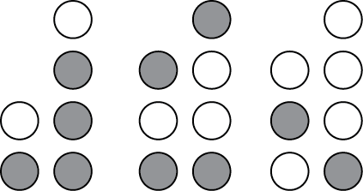

1. ***Which of these 4 numbers, given in hexadecimal format, correspond to blue in the RGB system?***
   * + 1. #FF0000
       2. #00FF00
       3. **#0000FF**
       4. #FFFFFF
2. ***Which of the following expression is NOT a valid html tag:***
3. <body>
4. </html>
5. **<body />**
6. <li>
7. ***The heart rate of a young athlete can go as high as 180 beats per minute. What is the most appropriate sampling rate to use if you want to monitor heart rate during exercise?***
   * + 1. 1 Hz,
       2. **8 Hz,**
       3. 5 Hz,
       4. 3 Hz.
8. ***Which of these devices is NOT an input device for a computer?***
   * + 1. Keyboard
       2. Touchscreen
       3. Microphone
       4. **Printer**
9. ***Which of these devices cannot be assimilated to, or does not contain a computer?***
   1. Smartphone
   2. Electronic book reader
   3. **Slide ruler**
   4. Notebook
10. ***You take a picture with a digital camera and you know that this picture requires 64 Mbytes of storage (without compression). Assuming that each pixel is stored on 32 bits, what is the resolution of your camera, in megapixels:***
    * + 1. **16**
        2. 12
        3. 4
        4. 32
11. ***The hexadecimal equivalent of 1110010 is***
12. 82
13. 71
14. **72**
15. F2

**Part II (four problems; total 40 points)**

1) Based on the logic tables for the three basic gates AND, OR, and NOT given below, find the logic table associated with the “new” gate X: ***(10 points)***

2) The five bytes written below represent an acronym based on the ASCII code. Decode these bytes and find the corresponding acronym. Show your work ***(10 points)***

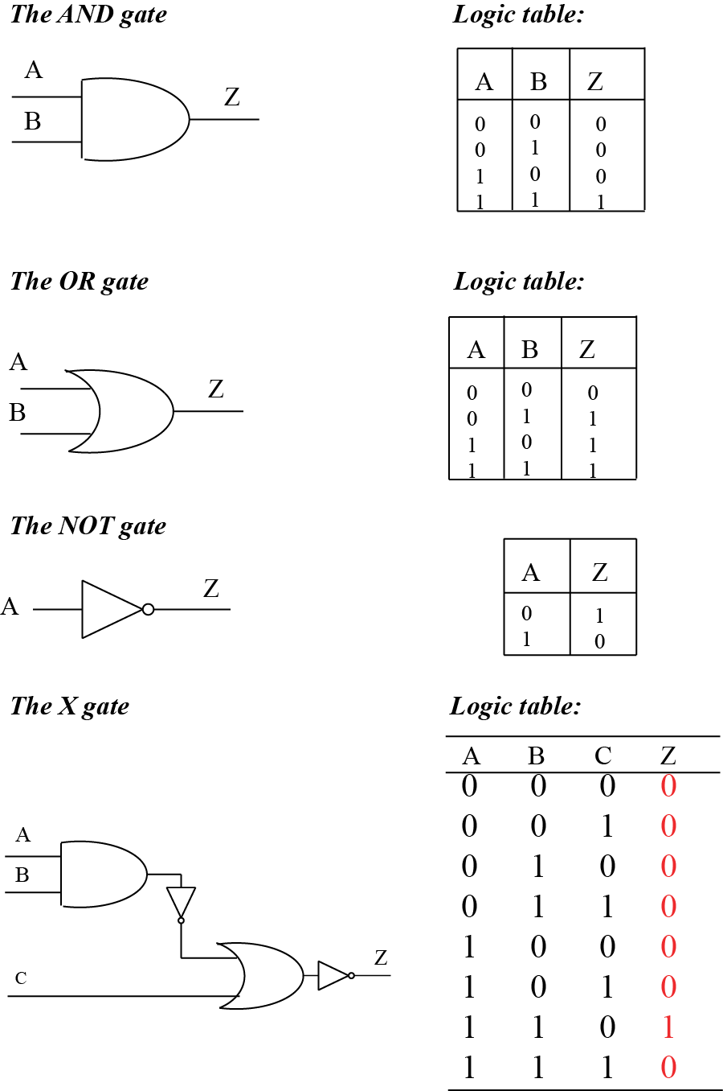

**01000101 01000011 01010011 00110001 00110101**

**01000101 -> 0100 0101 -> #45 -> E**

**01000011 -> 0100 0011 -> #43 -> C**

**01010011 -> 0101 0011 -> #53 -> S**

**00110001 -> 0011 0001 -> #31 -> 1**

**00110101 -> 0011 0101 -> #35 -> 5**

**The word is: ECS15**

3) The table below shows three problems that can occur on a computer. For each of these problems, identify at least one possible cause ***(10 points)***

|  |  |
| --- | --- |
| **Problem** | **Possible cause ()** |
| The computer fails the POST | * + - A critical device (keyboard, screen, hard drive,…) is either missing or not functioning     - Memory is not functioning |
| The computer passes the POST, but it does not boot | * + - The Master Boot Record is corrupted     - There are no operating systems available |
| The computer starts thrashing | There is not enough memory available, most lkely because too many applications are running simultaneously |

4) List at least 5 types of buses found on the motherboard of a computer ***(10 points).***

-**Front side bus**

**- Memory bus**

**- ATA bus**

**- AGP bus**

**- ISA bus**

**- Backside bus**