ECS 129: Structural Bioinformatics
March 18, 2024
Notes:
- The final exam is open book, open notes.
- The final is divided into 2 parts and graded over 80 points.
- You can answer directly on these sheets (preferred), or on loose paper.
- Please write your name at least on the front page!
- Please, check your work! If possible, show your work when multiple steps are involved.

Part I (15 questions, each 4 points; total 60 points)
(These questions are multiple choices; in each case, find the most plausible answer)

1) Sickle cell anemia results from a single amino acid change in the human beta globin, from Glu to Val. The most probable corresponding mutation at the DNA level is:
- Substitutions of 3 nucleotides
- Insertion of 2 nucleotides
- Deletion of 1 nucleotide
- Substitution of 1 nucleotide
- Insertion of 3 nucleotides

2) In the dynamic programming matrix below, what is the score in the cell identified with an interrogation mark (?). Assume that the score for a perfect match is set to 10, the score of a mismatch is set to 0, and gap penalties are ignored.
 | A | Y | F | W | G | G
A | 10 | 0 | 0 | 0 | 0 | 0
Y | 0 | 20 | 10 | 10 | 10 | 10
G | 0 | 10 | 20 | 20 | ?

  - 10
  - 20
  - 30
  - 40
  - 0

3) Which of the following statements on the Needleman and Wunsch algorithm for pair-wise sequence alignment is most likely true?
    - The Needleman-Wunsch algorithm is based on dynamic programming and as such requires additive scores,
    - The Needleman-Wunsch algorithm is based on dynamic programming and as such requires multiplicative scores,
    - The Needleman-Wunsch algorithm generates a single optimal alignment,
    - The Needleman-Wunsch algorithm has a complexity of O(N⁵) and as such can only be used on very short sequences,
    - None of the above.

4) You are given a single strand of DNA. You are told that this sequence contains as many purines as pyrimidines, as many guanines as thymine, and that its complementary strand contains 10% more cytosine than thymine. How much cytosine (in percent) does it contain?
  - 10%,
  - 20%,
  - 30%,
  - 40%,
  - Not enough information

5) The figure below shows the CD spectra of 3 proteins on the same plot.
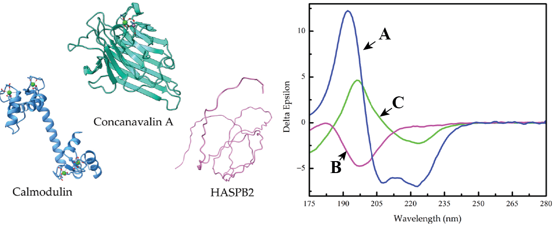
Identify A, B, and C:
- A: HASPB2, B: Calmodulin, C: Concanavalin A
- A: Concanavalin A, B: Calmodulin, C: HASPB2
- A: HASPB2, B: Concanavalin A, C: Calmodulin
- A: Calmodulin, B: HASPB2, C: Concanavalin A
- A: Calmodulin, B: Concanavalin A, C: HASPB2

6) The cDNA corresponding to a small peptide is ATGTATGATCAATGCAGCGGGCCTTTA TAG. The corresponding amino acid sequence is Met-Tyr-Asp-Glu-Cys-Ser-Gly-Pro-Leu. A mutation occurs at the DNA level, with the C at position 15 being substituted with T. What effect do you think this mutation might have on the expression of this gene?
- It introduces a stop codon and the peptide will be shorter
- The Cys in position 5 of the protein sequence will be replaced with Trp
- The Start and Stop codons won’t be in phase anymore and the gene won’t be expressed
- This is a silent mutation as it will have no impact on the protein sequence
- None of the above
7) A protein sequence contains one ASP residue. You want to create a new protein sequence, with this ASP being replaced with a TRP. To do this, you first generate the DNA corresponding to the original protein (with your own choice for the codons you use), then mutate this DNA to get the sequence corresponding to the new protein. What is the minimum number of mutations needed?

- 1
- 2
- 3
- 0
- None of the above
8) We want to find the best alignment(s) between the DNA sequences AGTATCT and AGATGC. The scoring scheme S is defined as follows: S(i,j) = 1 if i = j, and S(i,j) = 0 otherwise. There is a constant gap penalty of -1 (penalty for the first position counts; see table below). The score Sbest and the number N of optimal alignments are (show your final dynamic programming matrix and the best possible alignment (s) for full credit):
 | A | T | T | A | T | T | C
A | 1 | -1 | -1 | 0 | -1 | -1 | -1
T | -1
A | 0
T | -1
T | -1
C | -1
- Sbest = 5, N = 2
- Sbest = 3, N = 1
- Sbest = 5, N = 1
- Sbest = 3, N = 2
- None of the above
9) Which combination of program / substitution matrix will most likely give you the best alignment between two sequences that are very similar?
- BLAST / Blosum45
- Dynamic programming / Blosum45
- BLAST / Blosum90
- Dynamic programming / Blosum90
- BLAST / Blosum10
10) The best alignment found between the 2 DNA sequences TATATTC and ATCTC is:
TATATTC
-AT-CTC
The scoring scheme S is defined as follows: S(i,i) = 2X and S(i,j) = X if i and j are different. There is a constant gap penalty of -1. Note that a gap at the beginning does not count. The score of this alignment is 26. What is the value of X?
  - X = 2
  - X = 3
  - X = 4
  - X = 5
  - None of the above

11) How many possible alignments, with no internal gaps, can you form when you compare a sequence of length 7 with a sequence of length 12? (Note that an alignment must have at least one letter match between the 2 sequences)
- 7
- 12
- 19
- 17
- 18
12) The Ramachandran plot of the protein structure 1bww is given below.
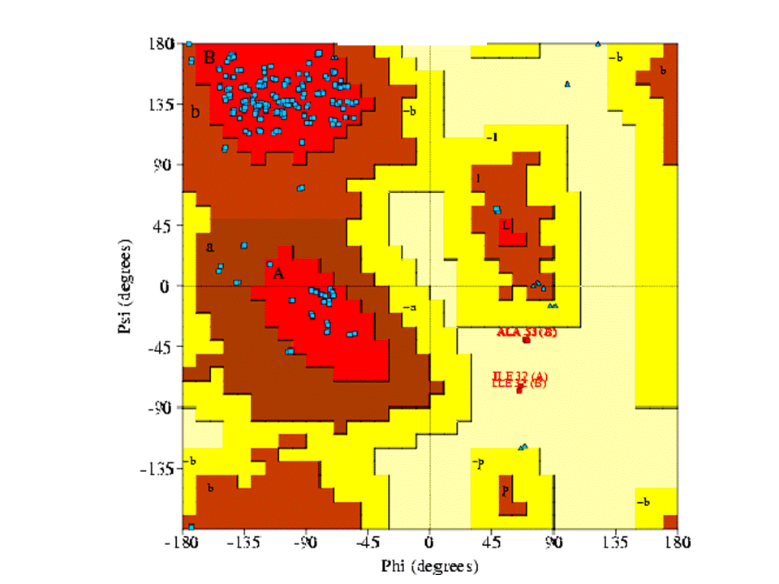

Which of the model of protein structures given below is most likely the corresponding structure

13) The Ramachandran plot of the protein structure 1tim is given below.
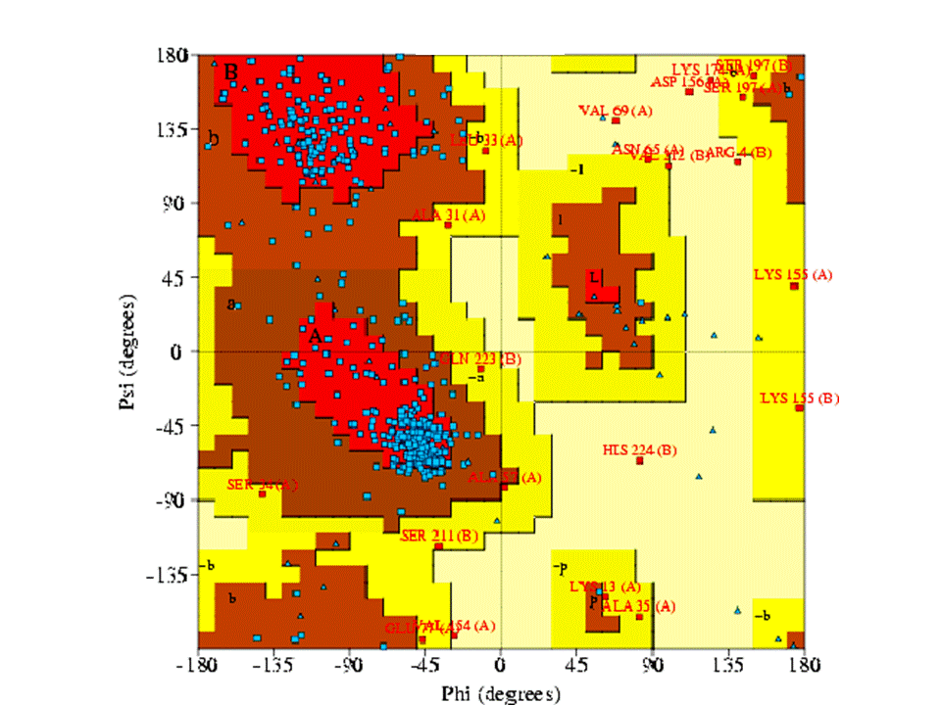

Which of the model of protein structures given below is most likely the corresponding structure:

14) The codon for Tryptophane is UGG. How many different amino acids (not including Tryptophane) could possibly result from substitutions of the first base, the second base, or both (the third base will always be G)?
- 16
- 13
- 14
- 12
- Not enough information available

15) Only one of those statements is correct when referring to the RMSD between two protein structures:
- RMSD is computed from the dihedral angles of a structure
- The larger the RMSD, the closer the two structures are
- RMSD is equal to the score of the sequence alignment between two protein structures, squared
- The expected RMSD between two experimental structures of the same protein in the same condition is expected to be below 1 Å
- The expected RMSD between two experimental structures of the same protein in the same condition is expected to be above 5 Å

Part II (2 problems, total 20 points)

Problem 1 (10 points)

- (5 points) Perform a global alignment of the two peptides AGPES and GCAET. The scoring scheme S is defined as follows: S(i,j) = 10 if i=j, and S(i,j) = 0 otherwise. There is a constant gap penalty of -1. Note that a gap at the beginning counts. After filling out the matrix, circle the traceback path(s) and write the optimal alignment(s). Note that if there are multiple traceback paths, write out all the optimal alignments.

- (5 points) Perform the same global alignment, but now using the BLOSUM62 matrix provided in the appendix to define the score. There is again a constant gap penalty of -1. Note that a gap at the beginning counts. After filling the matrix, circle the traceback path(s) and write the optimal alignment(s). Note that if there are multiple traceback paths, write out all the optimal alignments. Explain possible differences with part a).

Problem 2 (10 points)
A friend working in a biochemistry lab gave you a small sample. They told you that they know it contains a fragment of a protein, F, but they don’t know more and would like you to investigate. You first find its sequence using Edman degradation: the fragment contains 57 amino acids. You decide then to check if the structure of this protein has already been studied. You use BLAST for this. Surprisingly, the top hit with BLAST shows three matches within the sequence of 8E0N, a protein that is found in anti-aging serum. Here are the corresponding BLAST results:

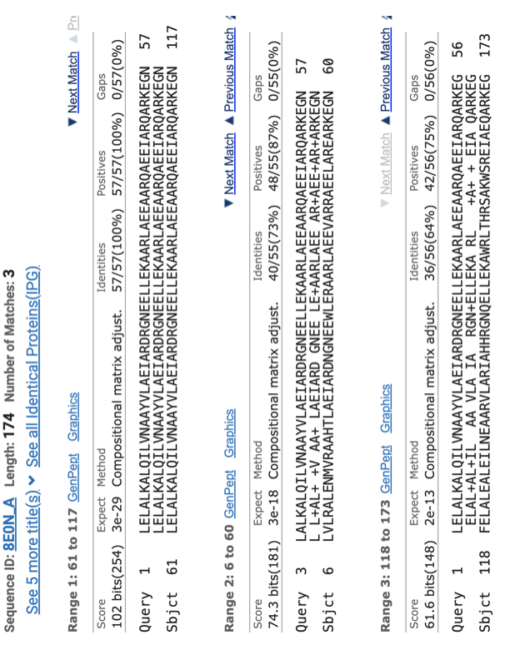

- (4 points) BLAST found three alignments. Are these alignments significant? Justify your answer

- (4 points) Based on these results from BLAST, draw schematically the dotplot between your protein and 8E0NA. Only show the major correspondences between the two sequences

- (2 points) From these results, can you say anything about the structure of your protein, and the structure of 8E0NA ? Justify your answer.

Appendix A: Genetic Code
 | U | C | A | G
U | Phe  Phe  Leu  Leu | Ser  Ser  Ser  Ser | Tyr  Tyr  STOP  STOP | Cys  Cys  STOP  Trp | U  C  A  G
C | Leu  Leu  Leu  Leu | Pro  Pro  Pro  Pro | His  His  Gln  Gln | Arg  Arg  Arg  Arg | U  C  A  G
A | Ile  Ile  Ile  Met/Start | Thr  Thr  Thr  Thr | Asn  Asn  Lys  Lys | Ser  Ser  Arg  Arg | U  C  A  G
G | Val  Val  Val  Val | Ala  Ala  Ala  Ala | Asp  Asp  Glu  Glu | Gly  Gly  Gly  Gly | U  C  A  G
Appendix B: Blosum62 matrix
 | C | S | T | P | A | G | N | D | E | Q | H | R | K | M | I | L | V | F | Y | W
C | 9 | -1 | -1 | -3 | 0 | -3 | -3 | -3 | -4 | -3 | -3 | -3 | -3 | -1 | -1 | -1 | -1 | -2 | -2 | -2
S | -1 | 4 | 1 | -1 | 1 | 0 | 1 | 0 | 0 | 0 | -1 | -1 | 0 | -1 | -2 | -2 | -2 | -2 | -2 | -3
T | -1 | 1 | 4 | 1 | -1 | 1 | 0 | 1 | 0 | 0 | 0 | -1 | 0 | -1 | -2 | -2 | -2 | -2 | -2 | -3
P | -3 | -1 | 1 | 7 | -1 | -2 | -1 | -1 | -1 | -1 | -2 | -2 | -1 | -2 | -3 | -3 | -2 | -4 | -3 | -4
A | 0 | 1 | -1 | -1 | 4 | 0 | -1 | -2 | -1 | -1 | -2 | -1 | -1 | -1 | -1 | -1 | -2 | -2 | -2 | -3
G | -3 | 0 | 1 | -2 | 0 | 6 | -2 | -1 | -2 | -2 | -2 | -2 | -2 | -3 | -4 | -4 | 0 | -3 | -3 | -2
N | -3 | 1 | 0 | -2 | -2 | 0 | 6 | 1 | 0 | 0 | -1 | 0 | 0 | -2 | -3 | -3 | -3 | -3 | -2 | -4
D | -3 | 0 | 1 | -1 | -2 | -1 | 1 | 6 | 2 | 0 | -1 | -2 | -1 | -3 | -3 | -4 | -3 | -3 | -3 | -4
E | -4 | 0 | 0 | -1 | -1 | -2 | 0 | 2 | 5 | 2 | 0 | 0 | 1 | -2 | -3 | -3 | -3 | -3 | -2 | -3
Q | -3 | 0 | 0 | -1 | -1 | -2 | 0 | 0 | 2 | 5 | 0 | 1 | 1 | 0 | -3 | -2 | -2 | -3 | -1 | -2
H | -3 | -1 | 0 | -2 | -2 | -2 | 1 | 1 | 0 | 0 | 8 | 0 | -1 | -2 | -3 | -3 | -2 | -1 | 2 | -2
R | -3 | -1 | -1 | -2 | -1 | -2 | 0 | -2 | 0 | 1 | 0 | 5 | 2 | -1 | -3 | -2 | -3 | -3 | -2 | -3
K | -3 | 0 | 0 | -1 | -1 | -2 | 0 | -1 | 1 | 1 | -1 | 2 | 5 | -1 | -3 | -2 | -3 | -3 | -2 | -3
M | -1 | -1 | -1 | -2 | -1 | -3 | -2 | -3 | -2 | 0 | -2 | -1 | -1 | 5 | 1 | 2 | -2 | 0 | -1 | -1
I | -1 | -2 | -2 | -3 | -1 | -4 | -3 | -3 | -3 | -3 | -3 | -3 | -3 | 1 | 4 | 2 | 1 | 0 | -1 | -3
L | -1 | -2 | -2 | -3 | -1 | -4 | -3 | -4 | -3 | -2 | -3 | -2 | -2 | 2 | 2 | 4 | 3 | 0 | -1 | -2
V | -1 | -2 | -2 | -2 | 0 | -3 | -3 | -3 | -2 | -2 | -3 | -3 | -2 | 1 | 3 | 1 | 4 | -1 | -1 | -3
F | -2 | -2 | -2 | -4 | -2 | -3 | -3 | -3 | -3 | -3 | -1 | -3 | -3 | 0 | 0 | 0 | -1 | 6 | 3 | 1
Y | -2 | -2 | -2 | -3 | -2 | -3 | -2 | -3 | -2 | -1 | 2 | -2 | -2 | -1 | -1 | -1 | -1 | 3 | 7 | 2
W | -2 | -3 | -3 | -4 | -3 | -2 | -4 | -4 | -3 | -2 | -2 | -3 | -3 | -1 | -3 | -2 | -3 | 1 | 2 | 11

