ECS 129: Structural Bioinformatics
March 16, 2026
Notes:
- The final exam is open book, open notes.
- The final is divided into 3 parts and graded over 100 points.
- You can answer directly on these sheets (preferred), or on loose paper.
- Please write your name at least on the front page!
- Please, check your work! If possible, show your work when multiple steps are involved.

Part I (15 questions, each 4 points; total 60 points)
(These questions are multiple choices; in each case, find the most plausible answer)

1) In the dynamic programming matrix below, what is the score in the cell identified with an interrogation mark (?). Assume that the score for a perfect match is set to 10, the score of a mismatch is set to -3, and gap penalties are ignored.
  - 10
  - 20
  - 30
  - 40
  - 0

 | A | T | C | Y | A | G
A | 10 | -3 | -3 | -3 | 10 | -3
Y | -3 | 7 | 7 | 20 | 7 | 7
G | -3 | 7 | 4 | 4 | 17 | ?

2) We want to find the best alignment(s) between the protein sequences FAFWC and FWFC. The scoring scheme S is defined as follows: S(i,i) = P, and S(i,j) = M otherwise. There is a constant gap penalty of G (gaps at the beginning are considered). The dynamic programming matrix is shown below. What are the values of P, M, and G?
 | F | A | F | W | C
F | 5 | -4 | 3 | -4 | -4
W | -4 | 3 | 1 | 8 | 1
F | 3 | 1 | 8 | -1 | 6
C | -4 | 1 | -1 | 6 | 11

a) P= 5, M=0, G=0
b) P= 5, M=-1, G=-1
c) P= 5, M=-2, G=-2
d) P= 5, M=-3, G=-1
e) P=5, M=-1, G=-3

3) Which of the following statements on the Smith and Waterman algorithm for pair-wise sequence alignment is most likely true?
    - The dynamic programming matrix for the Smith and Waterman algorithm only includes non-negative values,
    - The Smith and Waterman algorithm is based on dynamic programming and as such requires multiplicative scores,
    - Contrary to the Needleman and Wunsch algorithm, the Smith and Waterman algorithm generates a single optimal alignment,
    - The Smith and Waterman algorithm has a complexity of O(N⁵) and as such can only be used on very short sequences,
    - None of the above.
4) You are given the task to find the structure of human DNAJA1, a heat shock co-chaperone involved with proteostasis. You have a sample of the protein in solution, and you were able to generate its CD spectrum (left, below). As you are in a hurry, instead of trying to find its 3D structure experimentally, you use AlphaFold and find the structure shown on the right, below.
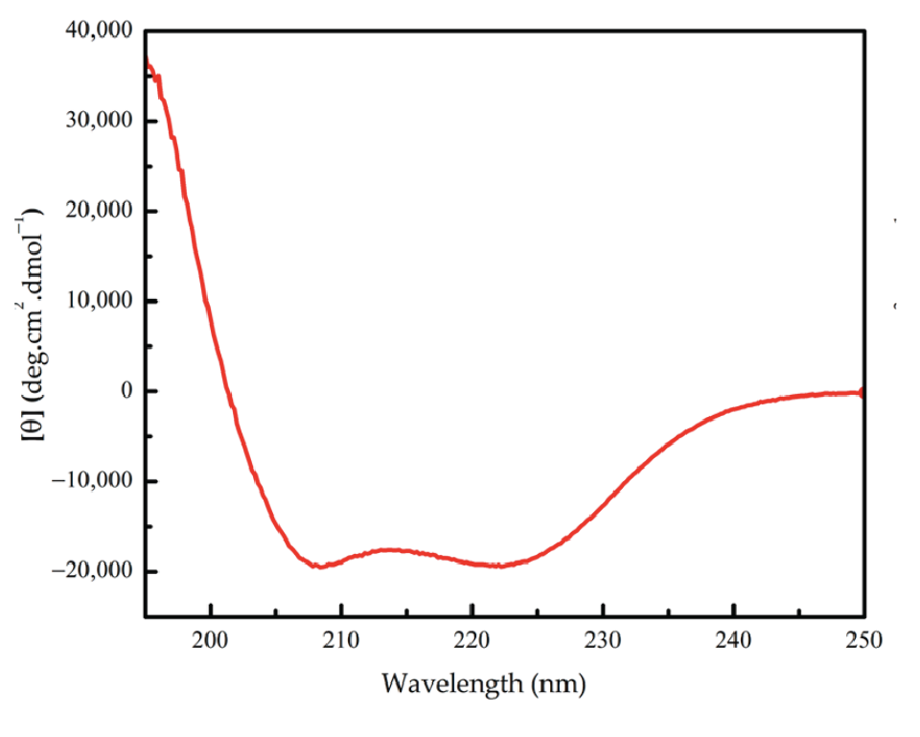

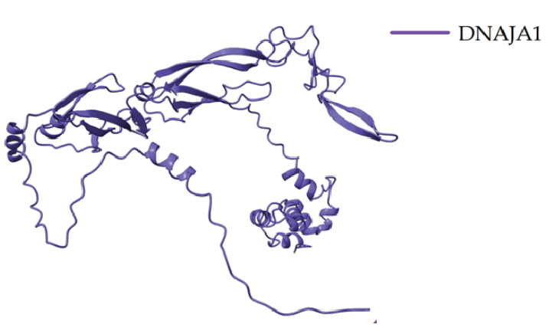

Based on your understanding of CD spectra,
- The AlphaFold prediction is spot on as the CD spectrum is typical of a protein with a lot of coil regions and many β-sheets
- The AlphaFold prediction is mostly correct as the CD spectrum shows that the protein has many coil regions
- The AlphaFold prediction should be questioned: the CD spectrum reveals a mostly helical protein.
- I cannot say as the CD spectrum does not provide information on the structure of a protein.

5) You are given a single strand S of DNA. You are told that this sequence contains 20 % of Adenine and that the corresponding double stranded DNA contains 46% of GC base pairs. How much thymine (in percent) does S contain?
  - 10%,
  - 20%,
  - 34%,
  - 44%,
  - Not enough information

- The best global alignment found between sequences TATC and TTC
is: TATC
T-TC. It has a total score of 12. The scoring scheme uses a match score of 5 and a mismatch score of -2. What is the constant gap penalty d used for this alignment?
- 0
- -1
- -2
- -3
- None of the above

7) A protein sequence contains one Histidine (HIS) residue. You want to create a new protein sequence, with this HIS being replaced with a Methionine (MET). To do this, you first generate the DNA corresponding to the original protein, then mutate this DNA using only substitution to get the sequence corresponding to the new protein. What is the minimum number of mutations needed?
- 1
- 2
- 3
- 0

8) The figure below illustrates the thermal unfolding of recombinant human Apo A-1 as seen by CD spectroscopy. Apo A-1 is a mostly helical protein. Note that increase in temperature leads to unfolding, i.e., loss of structure, including secondary structures).
The CD spectra were recorded between 5°C and 90°C recorded in 5°C steps. Which temperatures do you think the spectra A and B correspond to:
- A: 5°C and B: 90°C
- A: 90°C and B: 5°C

9) We want to find the best alignment(s) between the DNA sequences TAGCTTG and AGTTTG. The scoring scheme S is defined as follows: perfect matches have a score of 2, while mismatches have a score of 0. There is a constant gap penalty of -1 (penalty for the first position counts; see table below). The score Sbest and the number N of optimal alignments are (show your final dynamic programming matrix and the best possible alignment (s) for full credit):
 | T | A | G | C | T | T | G
A | 0 | 1 | -1 | -1 | -1 | -1 | -1
G | -1
T | 1
T | 1
T | 1
G | -1
- Sbest = 7, N = 2
- Sbest = 9, N = 1
- Sbest = 9, N = 2
- Sbest = 7, N = 1
- None of the above
10) You are trying to align two protein sequences that share only 18% sequence identity. Which combination of program and substitution matrix is most appropriate for finding a biologically meaningful alignment between domains of those two sequences?
a) Smith and Waterman / Blosum90
- Needleman and Wunsch / Blosum45
- BLAST / Blosum90
- Needleman and Wunsch / Blosum90
- Smith and Waterman / Blosum45
11) The two Ramachandran plots relate to the same protein, cellular retinoic acid binding protein type II. One is based on the experimental X-ray structure of the protein (at 1.8 Angstroms resolution), while the other is from an intentionally bad model of the same protein. Can you guess which one is which?
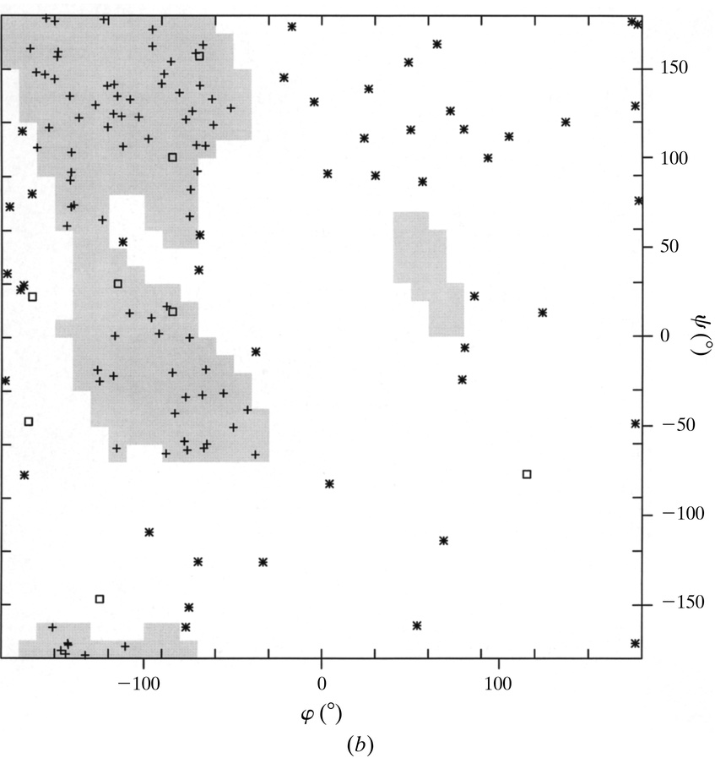
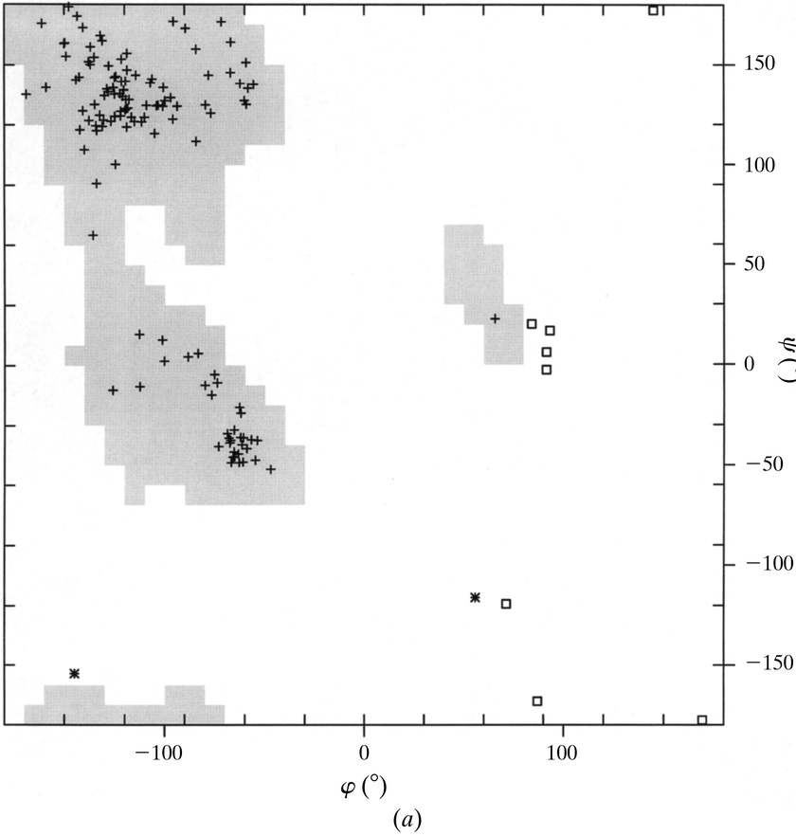

  - (a, left) corresponds to the experimental structure, while (b, right) is the bad model
  - (a, left) is the bad model, while (b, right) corresponds to the experimental structure
  - It is impossible to say from just the Ramachandran plots

12) The mRNA sequence 5’-AUG AAA UGC GUU AAC UAA-3’ codes for the small peptide Met-Lys-Cys-Val-Asn. The first G from the 5’ end is mutated to a U. The new mRNA sequence codes for
- Ile-Lys-Cys-Val-Asn
- Lys-Cys-Val-Asn
- Met-Arg
- Met-Arg-Asn
- None of the above as the new sequence does not contain a START or a STOP codon

13) Which of the following best describes the function and processing of exons and introns?
- Both introns and exons are translated into proteins in the cytoplasm.
- Introns are spliced out of the mature mRNA, while exons are joined together to be translated.
- Exons are removed from the pre-mRNA, while introns are joined together.
- Introns are the coding sequences, and exons are the non-coding sequences.

14) The best alignment found between the 2 DNA sequences TAGATGC and TGTCAC is:
TAGATGC
T-GTCAC
The scoring scheme S is defined as follows: S(i,i) = 3X, S(i,j) = 2X if i and j are different purines, S(i,j)=X if i and j are different pyrimidine, and S(i,j)=0 otherwise. There is a constant gap penalty of -1. The score of this alignment is 35. What is the value of X?
- X = 2
- X = 3
- X = 4
- X = 5
- None of the above

15) Which of the following is a known limitation of AlphaFold?
a) It cannot predict structures for proteins with more than 10 amino acids.
b) It struggles with modeling intrinsically disordered regions and ligand-bound states.
c) It is slower than traditional experimental methods.
d) It only works for human proteins.

Part II (2 problems, total 40 points)

Problem 1 (20 points)

We want to find the best local alignment(s) between the protein sequences S1=WCAPT and S2=PTWCA. The scoring scheme S is defined as follows: S(i,i) = P (perfect match), and S(i,j) = M otherwise (mismatch). There is a constant gap penalty of G (gaps at the beginning count). Note that M and G are negative. The partial dynamic programming matrix (based on local alignment) is shown below:

 | W | C | A | P | T
P | 0 | 0 | 0 | 9 | 0
T |  |  |  |  | 19
W |  |  |  |  | 5
C |  |  |  |  | 5
A |  |  |  |  | 15

- (10 points) Can you find P, M, and G. Explain your work

- (5 points) Complete the local dynamic programming matrix and find the best local alignment(s)

- (5 points) Build a simple dotplot between S1 and S2 (assuming a dot is only present for a perfect match). What does it reveal that is not seen from the dynamic programming matrix?

Problem 2 (20 points)
1) (10 points) The following eukaryotic DNA sequence was given to you:
5’-CCCTTAATGCGTATCGCTCACCATGCGATACGCATGTAA-3’
You are told that this sequence, or its complementary, codes for one gene.
Find the longest “gene” corresponding to this DNA sequence; remember that there are 6 possibilities, i.e. 3 possible reading frames for one strand and 3 possible reading frames for its complementary.
Transcribe this gene into an RNA sequence and then translate it into a protein sequence

2) (10 points) Draw schematically the dotplot of this protein sequence against itself. What does this dotplot reveal?

Appendix A: Genetic Code
 | U | C | A | G
U | Phe  Phe  Leu  Leu | Ser  Ser  Ser  Ser | Tyr  Tyr  STOP  STOP | Cys  Cys  STOP  Trp | U  C  A  G
C | Leu  Leu  Leu  Leu | Pro  Pro  Pro  Pro | His  His  Gln  Gln | Arg  Arg  Arg  Arg | U  C  A  G
A | Ile  Ile  Ile  Met/Start | Thr  Thr  Thr  Thr | Asn  Asn  Lys  Lys | Ser  Ser  Arg  Arg | U  C  A  G
G | Val  Val  Val  Val | Ala  Ala  Ala  Ala | Asp  Asp  Glu  Glu | Gly  Gly  Gly  Gly | U  C  A  G

