ECS 17: Data, Logic, and Computing
Final
March 19, 2024

Notes:
- The final is open book, open notes.
- You have 2 hours, no more: I will strictly enforce this.
- The final is graded over 100 points
- Please, check your work! Also, do show your work

Part I Data (10 questions, each 3 points; total 30 points)
(These questions are multiple choices; in each case, find the most plausible answer)

- Which binary number is (101111)₂ + 1 equal to?
      - (101112)₂
      - (101110)₂
      - (111111)₂
      - (110000)₂

- How much space would you need to store a 10 min song that has been sampled at 44.1 KHz, with each data point stored on 8 bits, in quadrophony (i.e. using 4 microphones to record the song; assume no compression)?
  - About 100 MBytes
  - About 100 Mbits
  - About 50 Mbytes
  - About 5 Mbytes

- (1101)₂ –(110)₂ =
  - #B
  - #7
  - #A
  - #6

- #C9-#B3=
      - (10110)₂,
      - (11110)₂,
      - (10111)₂,
      - (11111)₂.

- Assuming that there are 400,000 characters in the UNICODE, what is the minimal number of bits needed to store a word of 8 characters with this code?
  - 19,
  - 190,
  - 152,
  - 148.

- If a signal is thought to have a maximum frequency between 1000 Hz and 4000 Hz, which of the following would be the most appropriate sample rate?
  - 500 Hz,
  - 4000 Hz,
  - 8000 Hz,
  - 9000 Hz.

- As you are reading a paper, you see the word LOA_ (upper case), where the underscore is unfortunately a letter you cannot read. You know, however, that the sum of all ASCII identifiers for this word is #120. What is the missing letter represented as the underscore
- S,
- F,
- D,
- N.

- Let A be the hexadecimal number #F1 and B the hexadecimal number #101; which of these hexadecimal numbers C satisfies A+C = B?
  - #A0,
  - #10,
  - #11,
  - #1F2.

- Mannikins are birds that can flap their wings up to 100 times a second. Which of these sampling rates is most appropriate to use if you want to monitor the flight of a mannikin correctly with a digital device?
      - 3 Hz,
      - 30 Hz,
      - 300 Hz,
      - 100 Hz.

- The gate shown below is equivalent to:
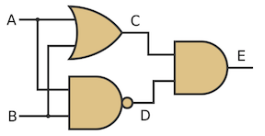
- The AND gate,
- The OR gate,
- The XOR gate,
- The XNOR gate.

Part II Logic (three problems; total 30 points)

1) For each of the five propositions in the table below, indicates on the right if they are always tautologies or not (x is a real number, p and q are propositions, T is a tautology, and F a contradiction) (10 points).

Proposition | Tautology (Yes or No)
If $x^{4}=-x^{2}-1$ then 25=23+3
$$\left(p∧¬p\right)→q$$
$$\left(p∨F\right)→p$$
$$\left(p→q\right)↔\left(¬p∨q\right)$$
$$\left(p∧¬q\right)∨\left(¬p∧q\right)$$

2) Inspector Craig from Scotland Yard has been assigned a special mission: identify a knave on an island that otherwise is inhabited only by knights. This island, however, is unusual: knights always tell the truth in the morning and always lie in the afternoon, while knaves always lie in the morning and tell the truth in the afternoon. As he arrives on the island, he is presented with 3 inhabitants, Alice, Ben, and Claire. He is told that one of them is the knave he is looking for (the two others are then knights). Unfortunately, he does not know if it is currently morning or afternoon. Alice tells him, “if I am a knave, it is currently morning”, while Claire tells him that “Alice is a knave”. Can you help Inspector Craig find the knave? Can you also tell him if it is morning or afternoon? (10 points)

- 3) Let p and q be two propositions. Use a truth table or logical equivalence to show that the proposition is a tautology. (10 points)

Part III. Proofs (4 questions; each 10 points; total 40 points)

1) Let n be an integer. Show that n is odd if and only if $n^{2}-1$ is a multiple of 8 (note that an integer n is a multiple of 8 if and only if there exists an integer k such that n = 8k).

2) Use induction to prove that any postage value of n cents can be made with only 5-cent stamps and 7-cent stamps, whenever $n≥24$, n natural number.

3) Let $u_{n}$ be the sequence of real numbers defined by:

$$u_{0}=3$$

$$u_{n+1}=\frac{u_{n}-2}{2u_{n}+5}$$
We will assume that $u_{n}≠\frac{-5}{2}$, i.e. that the sequence is defined for all natural numbers n. Show that for all natural number n,
$$u_{n}=\frac{9-8n}{3+8n}$$

4) Let f_{n} be the n-th Fibonacci number (note: Fibonacci numbers satisfy f₀=0, f₁=1 and ). Prove by induction that for all natural numbers $n≥1$, $f_{3n} is even.$

Appendix A: ASCII table

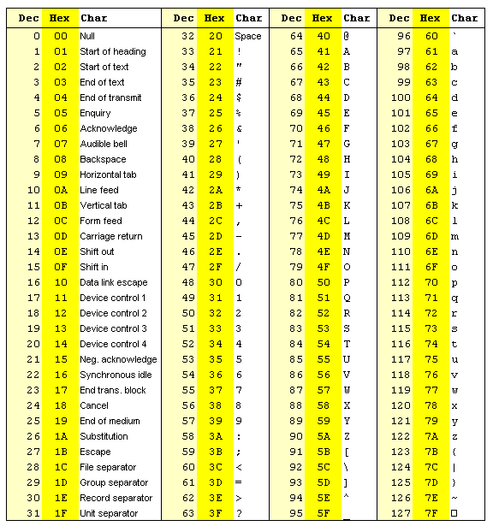

Appendix B: Binary to Hexadecimal

Base 10 | Base 2 | Base 16
0 | 0000 | 0
1 | 0001 | 1
2 | 0010 | 2
3 | 0011 | 3
4 | 0100 | 4
5 | 0101 | 5
6 | 0110 | 6
7 | 0111 | 7
8 | 1000 | 8
9 | 1001 | 9
10 | 1010 | A
11 | 1011 | B
12 | 1100 | C
13 | 1101 | D
14 | 1110 | E
15 | 1111 | F

Appendix C

