ECS 17: Data, Logic, and Computing
Final
March 18, 2025
Notes:
- The final is open book, open notes.
- You have 2 hours, no more: I will strictly enforce this.
- The final is graded over 100 points
- Please, check your work! Also, do show your work

Part I Data (10 questions, each 3 points; total 30 points)
(These questions are multiple choices; in each case, find the most plausible answer)

- Convert the binary number (1011010111001100)₂ to hexadecimal:
  - #B5CC
  - #B6CC
  - #D6CC
  - #D5CC

- What is the largest signed integer that can be stored in 4 bits?
  - 15
  - 16
  - 7
  - 8

- (1101)₂ + (1011)₂ =
  - #18
  - #1A
  - #1C
  - #1E

- A camera captures video at 24 frames per second. Which of these moving objects can be properly recorded (Select all that apply)
  - A hummingbird's wings flapping at 50 Hz
  - A ceiling fan rotating at 0.8 revolutions per second
  - A metronome moving at 30 beats per minute
  - A strobe light flashing 10 times per second

- A 1-minute video is captured with 30 frames per second, with each frame having a resolution of 1920×1080 pixels, and each pixel stored over 24-bit. What is the uncompressed file size in gigabytes (GB)? (Assume 1 GB = 10^9 bytes)
      - 8.9 GB
      - 11.2 GB
      - 3.7 GB
      - 5.6 GB

- Which binary number comes right before the binary number 1000?
  - 0999
  - 0111
  - 0100
  - 1001

- Decode the name whose ASCII representation is #54 #68 #6F #6D #61 #73
- Thomas
- THOMAS
- Thomes
- THOMES

- Let A be the number with the hexadecimal representation #A and B the number whose hexadecimal representation is #18; which of these numbers X (in hexadecimal form) satisfies X² – AX + B = 0 (circle all that apply):
  - #C
  - #4
  - #2
  - #6

- What time is it on this digital clock (dark circle mean “on”)?


- 21:24:16
- 21:24:17
- 21:34:16
- 21.34.17

- Let x be a hexadecimal digit (i.e. a number in {0, 1, 2, 3, 4, 5, 6, 7, 8, 9, A, B, C, D, E, F}. We know that #x3 + #2x = #BC (where # means that the numbers are given in hexadecimal format; for example, if x = 1, #x3 = #13 = (19)₁₀). Solve for x:

  - 7
  - 8
  - 9
  - A

Part II Logic (three problems; total 30 points)

1) For each of the five propositions in the table below, indicates on the right if they are always tautologies or not (p and q are propositions) (10 points).

Proposition | Tautology (Yes or No)
$$p→p$$
$$\left(p∨q\right)→(p∧q)$$
$$\left(p∧q\right)→\left(p∨q\right)$$
if 3+6 = 10 then 25=16+10
$$\left(p∧¬q\right)∨\left(¬p∨q\right)$$

2) Let p and q be two propositions. Use a truth table or logical equivalence to show that the proposition $\left[¬\left(p→q\right)\right]↔\left[p∧¬q\right]$is a tautology. (10 points)

3) Inspector Craig from Scotland Yard has been assigned a special mission: find a treasure supposedly hidden on an island where there is a single village. This village is inhabited only by truth-tellers and liars. Truth-tellers always tell the truth, while liars always lie. Inspector Craig meet two villagers, Daniel and Eve, and ask them about the treasure. Daniel says: "If I am a truth-teller, then the treasure is hidden in my house” while Eve says: "Daniel is a liar."
Can you help inspector Craig and tell him if the treasure is in Daniel’s house? Can you determine whether Daniel and Eve are truth-tellers or liars? Justify your answer. (10 points)

Part III. Proofs (4 questions; each 10 points; total 40 points)

1) Give a direct proof and an indirect proof of the proposition: if 2n⁵ + n²+4n+2 is odd, then n is odd, where n is a natural number.

2) Use induction to prove that any postage value of n cents can be made with only 4-cent stamps and 7-cent stamps, whenever $n≥18$, n natural number.

3) Let F_{n} be the n-th Fibonacci number (note: Fibonacci numbers satisfy F₀=0, F₁=1 and $F_{n}+F_{n+1}=F_{n+2}$ for $n≥0).$Prove by induction that for all natural numbers $n≥0$, $F_{5n}$ is a multiple of 5 (where “multiple of 5” means that there exits an integer m such that $F_{5n}=5m$).

4) Let $a_{n}$ be the sequence of integers defined by $a_{n}={3a}_{n-1}+2$ for n≥2, with $a_{1}=5$. Show using a proof by induction that $a_{n}-1$is divisible by 4, for all natural numbers n. (Reminder: $a_{n}-1$is divisible by 4 means that there exits an integer k such that $a_{n}-1=4k)$

Appendix A: ASCII table

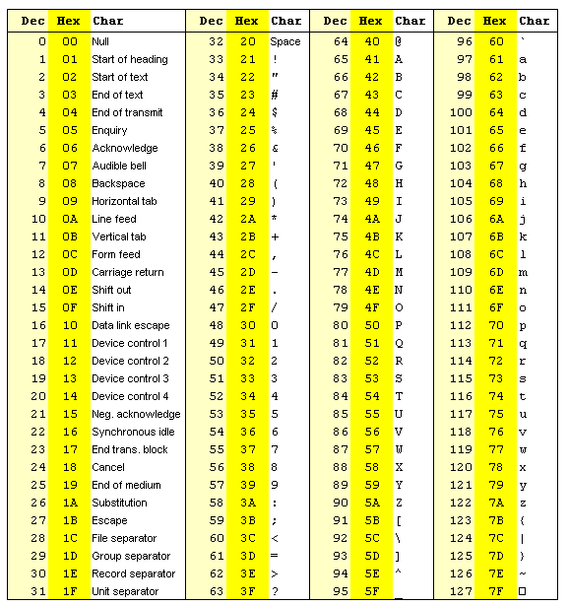

Appendix B: Binary to Hexadecimal

Base 10 | Base 2 | Base 16
0 | 0000 | 0
1 | 0001 | 1
2 | 0010 | 2
3 | 0011 | 3
4 | 0100 | 4
5 | 0101 | 5
6 | 0110 | 6
7 | 0111 | 7
8 | 1000 | 8
9 | 1001 | 9
10 | 1010 | A
11 | 1011 | B
12 | 1100 | C
13 | 1101 | D
14 | 1110 | E
15 | 1111 | F

Appendix C

