ECS 17: Data, Logic, and Computing
Final
March 16, 2026
Notes:
- The final is open book, open notes.
- You have 2 hours, no more: I will strictly enforce this.
- The final is graded over 100 points
- Please, check your work! Also, do show your work

Part I Data (10 questions, each 3 points; total 30 points)
(These questions are multiple choices; in each case, find the most plausible answer)

- (11111)₂+#AE:
  - (205)₁₀
  - (206)₁₀
  - (204)₁₀
  - (203)₁₀

- What is the largest unsigned integer that can be stored in 3 bits?
  - 7
  - 8
  - 15
  - 16

- (88)₁₀ + (10111)₂ =
  - #6F
  - #6E
  - #E6
  - #F6

- A smartphone camera is set to record slow-motion video at 60 frames per second. Which of the following continuous mechanical motions will be captured accurately without aliasing? (Select all that apply)
  - A car engine idling at 3000 RPM (Revolutions Per Minute)
  - A DJ's vinyl record spinning at 45 RPM
  - A power drill rotating at 15 Revolutions per second
  - An acoustic guitar's "A" string vibrating at 110 Hz

- A 1-minute video is captured with 30 frames per second, with each frame having a resolution of 1080×1080 pixels. How much space is used for each pixel if the video occupies approximately 4.2 gigabytes (GB)? (Assume 1 GB = 10^9 bytes)
      - 8 bits
      - 16 bits
      - 32 bits
      - 24 bits
- What is the binary representation of the number that is half the binary number (1000)₂?
  - (0500)₂
  - (0100)₂
  - (0010)₂
  - (0004)₂

- The sum of the ASCII codes for the word ECS17 is:
- #143
- #144
- #145
- #142

- Let n be the number with the hexadecimal representation #A and m the number whose hexadecimal representation is #18; which of these numbers X (in hexadecimal form) satisfies X² + nX - m = 0 (circle all that apply):
  - #D
  - #4
  - #2
  - #E

- A biologist wants to film a bee's wings flapping at 230 Hz and a moth's wings flapping at 40 Hz so that neither insect experiences the "wagon-wheel effect" on camera. Which of the following camera frame rates would successfully capture both? (Select all that apply)?
- 24 frame per seconds (fps)
- 60 fps
- 240 fps
- 500 fps

- Let x be a hexadecimal digit (i.e. a number in {0, 1, 2, 3, 4, 5, 6, 7, 8, 9, A, B, C, D, E, F}. We know that #xA + #Fx = #1A4 (where # means that the numbers are given in hexadecimal format; for example, if x = 1, #xA = #1A = (26)₁₀). Solve for x:

  - 7
  - A
  - B
  - C

Part II Logic (three problems; total 30 points)

1) For each of the five propositions in the table below, indicates on the right if they are always tautologies or not (n is an integer, p and q are propositions) (10 points).

Proposition | Tautology (Yes or No)
$$p→¬p$$
$$\left(¬p∧¬q\right)→(¬p∨¬q)$$
$$\left(p∧q\right)→\left(p∨q\right)$$
if $n^{2}+n$ is odd then n=5
$$\left(p∧¬p\right)∨\left(¬q∨q\right)$$

2) Let p and q be two propositions. Use a truth table or logical equivalence to show that the proposition $\left[\left(p→q\right)→p\right]→p$is a tautology. (10 points)

3) Commander Ripley is exploring a derelict space station trying to locate the vital "override key." The station's computer system has rebooted, and now its android crew is split into two factions: Security Droids and Corrupted Droids. Security Droids always tell the truth, while Corrupted Droids always lie. Ripley encounters two androids, Alpha and Beta.
- Alpha says: "If I am a Security Droid, then the override key is in the Reactor Core."
- Beta says: "Alpha is a Corrupted Droid."
Can you help Commander Ripley determine if the override key is in the Reactor Core? Can you figure out whether Alpha and Beta are Security Droids or Corrupted Droids? Justify your answer. (10 points)

Part III. Proofs (4 questions; each 10 points; total 40 points)

1) Use a proof by induction to show that $3^{n}-1$ is even, for all natural numbers n.

2) Let F_{n} be the n-th Fibonacci number (note: Fibonacci numbers satisfy F₀=0, F₁=1 and $F_{n}+F_{n+1}=F_{n+2}$ for $n≥0).$Prove by induction that for all natural numbers $n≥0$, $F_{4n}$ is a multiple of 3 (where “multiple of 3” means that there exits an integer m such that $F_{4n}=3m$).

3) Use induction to prove that any postage value of n cents can be made with only 3-cent stamps and 8-cent stamps, whenever $n≥15$, n natural number.

- Let n be a natural number and $a_{n}$ be the sequence of real numbers defined by
$a_{n+1}=\frac{a_{n}}{\sqrt{a_{n}^{2}+1}}$for n≥1, with $a_{1}=1$.
Show using a proof by induction that $a_{n}=\frac{1}{\sqrt{n}}$ for all natural numbers n.

Appendix A: ASCII table

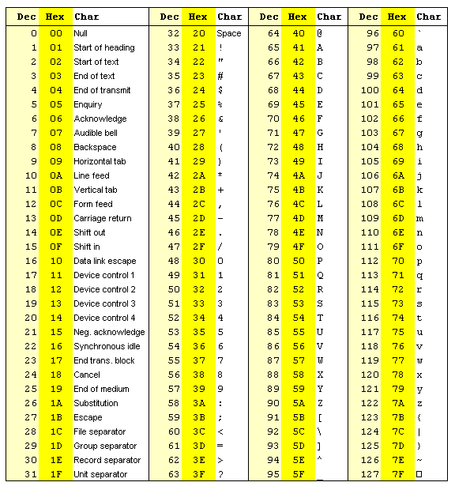

Appendix B

