ECS 17: Data, Logic, and Computing
Midterm 1
February 7, 2024

Notes:
- The midterm is open book, open notes.
- You have 50 minutes, no more: I will strictly enforce this.
- The midterm is graded over 70 points
- You can answer directly on these sheets (preferred), or on loose paper.
- Please write your name at the top right of each page you turn in!
- Please, check your work! Also, do show your work

Part I (6 questions, each 5 points; total 30 points)
(These questions are multiple choices; in each case, find the most plausible answer)

- The binary equivalent of the hexadecimal number #1A3 is:
  - (11010011)₂
  - (110100011)₂
  - (1001010011)₂
  - (11010)₂

- Let A be the number with the hexadecimal representation #C and B the number whose hexadecimal representation is #24; which of these numbers X (in hexadecimal form) satisfies X² – AX + B = 0?
  - #A
  - #B
  - #6
  - #7

- You want to store a silent movie on your computer. You know that your movie is 2 hour long, that it was filmed at a rate of 25 frames per second and that you need 10 kilobytes to store each frame. How much space to you need to store the whole movie, in megabytes (assuming that 1 megabyte = 1000 kilobytes)?
  - 1.8 megabytes
  - 1,800 megabytes (=1.8 GB)
  - 180,000 megabytes (=180 GB)
  - 36,000 megabytes (=3.6 GB)

- A heart monitor works with a sampling frequency of 6 Hz. Which of these animals can be correctly monitored when resting, given the ranges of their resting heart rates (circle all that apply)
      - Dog: 70-120 beats per minute,
      - Elephant: 25-35 beats per minute,
      - Chicken: 250-300 beats per minute,
      - Hamster: 300-600 beats per minute.
- If we sum the ASCII codes of the letters in a 2-letter word we get the hexadecimal #96. Which of those words would satisfy this property (circle all that are correct)?
      - AS
      - BT
      - ECS
      - CS

- The gate shown below is equivalent to:

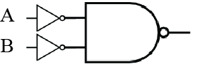

  - The NAND gate,
  - The AND gate,
  - The OR gate,
  - The NOR gate.

Part II (two problems, each 10 points; total 20 points)

- Complete the logic table corresponding to the logic gate shown below. Convert it into a Boolean expression. Can you find a simpler logic gate that would perform the same operation? (10 points)

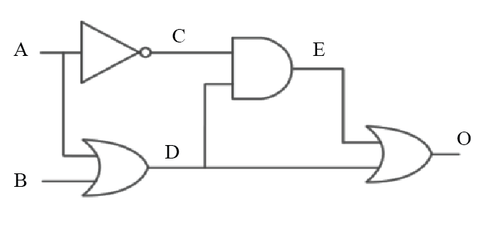
A | B | C | D | E | O
1 | 1
1 | 0
0 | 1
0 | 0

2) An engineer hands you a piece of paper with the following Boolean expression on it, and tells you to build a gate circuit to perform that function:
$$A⋅B + \overline{A}⋅\overline{B}$$
Draw a logic gate circuit for this function Represent its table of truth. Can you find a simpler logic gate that would perform the same operation? (10 points)

Part III (two problems, each 10 points; total 20 points)

1) Two guards are standing outside the entrance to a cave, guarding the treasure within. The treasure is one of copper, silver, gold, platinum, diamonds, or rubies. Guard 1 lies when guarding copper, silver, or gold and tells the truth when guarding other treasure. Guard 2, on the other hand, lies when guarding platinum, diamonds, or rubies, but tells the truth when guarding other treasure.
You meet the guards at the entrance to the treasure cave, and they make these statements:
- Guard 1 says: The treasure is either gold or copper.
- Guard 2 says: I hate chocolate.
If you determine the content of the cave, the guards will let you pass and you can claim the treasure. Will you be able to? In addition, does guard 2 really hate chocolate? Show your work (10 points)

2) In the strange community of Subterranea, visitors cannot tell day from night, but the residents can. The residents are of two types: day-knights or night-knights. Day-knights tell the truth during the day and lie at night, while night-knights tell the truth at night and lie during the day.

Suppose you are visiting Subterranea - naturally, you lose your sense of time and would like to know whether it is day or night. You encounter two inhabitants, John and Sally, and each makes a statement:
- John says: Sally is a day-knight, and it is day.
- Sally says: I am a night-knight, and John is a night-knight.
Is it day or night now? Show your work (10 points)

Appendix A: ASCII table

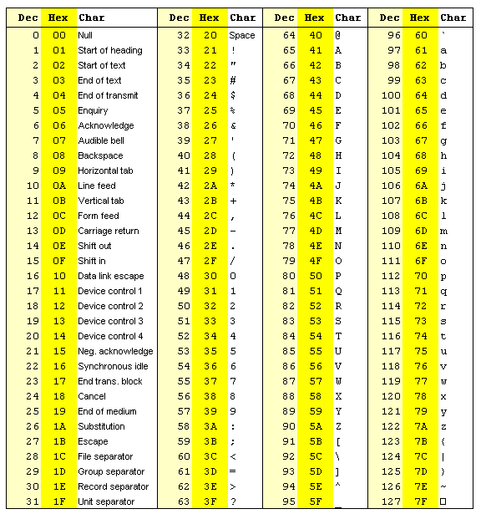

Appendix B: Binary to Hexadecimal

Base 10 | Base 2 | Base 16
0 | 0000 | 0
1 | 0001 | 1
2 | 0010 | 2
3 | 0011 | 3
4 | 0100 | 4
5 | 0101 | 5
6 | 0110 | 6
7 | 0111 | 7
8 | 1000 | 8
9 | 1001 | 9
10 | 1010 | A
11 | 1011 | B
12 | 1100 | C
13 | 1101 | D
14 | 1110 | E
15 | 1111 | F

