Large field of view (FOV) cellular resolution mapping of in vivo retinas by ultra- high resolution adaptive optics - optical coherence tomography (UHR-AO-OCT).
Robert J. Zawadzki, Julia W. Evans, Stacey S. Choi, Alfred R. Fuller, Bernd Hamann, John S. Werner
Vision Science and Advanced Retinal Imaging Laboratory (VSRI), Dept. of Ophthalmology & Vision Science, University of California Davis, Sacramento, CA
Visualization and Computer Graphics Research Group, Inst. for Data Analysis and Visualization (IDAV) and Dept. of Computer Science, UC Davis, Davis, CA
Department of Vision Science, The New England College of Optometry, Boston, MA

Purpose: To test the feasibility of UHR-AO-OCT for creating large field-of-view cellular-resolution retinal volumes.
Methods: An ultra-high resolution AO-FdOCT system (axial resolution, ~3.5 µm; lateral resolution, ~3.5 µm; acquisition speed: 18,000A–scans/s) constructed at UC Davis, was used for in vivo retinal imaging. The maximum lateral extent of a single UHR-AO-OCT volume acquired with this system is 1 mm (3 deg) due to the limited isoplanatic field with adaptive optics and instrument design. To overcome this limitation and to create retinal volumes that are similar in size to those of clinical FD-OCT systems, we acquired sets of UHR-AO-OCT sub-volumes at different retinal eccentricities with two different focus positions (one on inner retina and one on outer retina). Custom visualization software was used to stitch these sub-volumes in three dimensions into one large cellular resolution volume and then to co-register it with fundus photography.
Results: As an example, a 5x5 mm lateral size cellular resolution volume was constructed from 50 (5x5x2) single UHR-AO-OCT volumes. This large volume uses ~2.5 million A-scans (5000x500) and offers exceptional detail within large volumetric structures of living retina.
Conclusion: Large field-of-view cellular resolution mapping of the retina offers a complete volumetric representation of retinal structures that can be later accessed, viewed and studied. Despite current limitations of this technique (motion artifacts present within single UHR-AO-OCT volumes, as well as manual sub-volume acquisition and co-registration), this approach has significant potential for studying microscopic retinal changes associated with aging, progression of retinal disease or its treatment, without prior knowledge of the eccentricity or layers of interest.

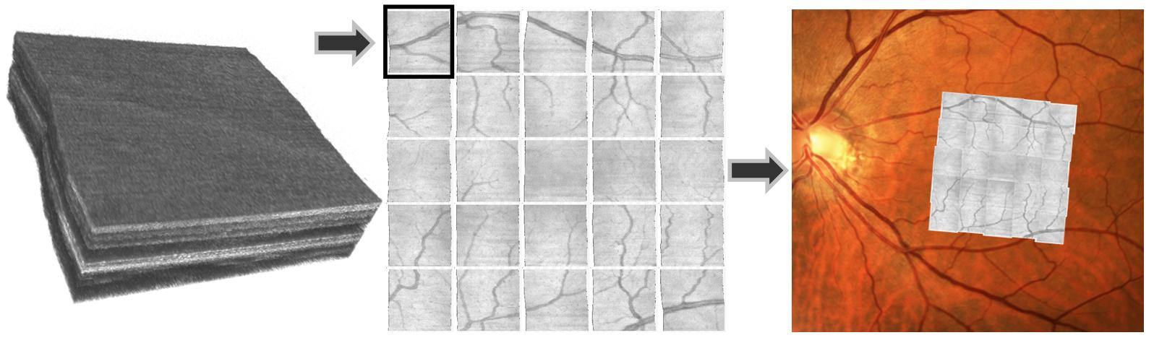

Grant Identification: National Eye Institute EY 014743 (JSW), Research to Prevent Blindness (RPB)

