**BL5229: Data Analysis with Matlab**

**Lab 1: Getting to know Matlab**

With this lab, you will start becoming familiar with the Matlab environment and some of its facilities. You will learn:

* How to perform basic arithmetic operations
* How to assign values to variables
* How to use control structures (do and if)
* How to generate graphics

**Exercise 1: Basic Arithmetic calculations within Matlab**

Evaluate the following expressions by hand and use Matlab to check the answers:

1. 1+2+3
2. 
3. log(e3) (lookup the functions **exp** and **log**)
4. 

**Exercise 2: assigning values to variables; basic operations on arrays**

Translate the following math statements into MATLAB commands. For help, the values for the function when x = [1 2 3] are given.

1. 

ans =

0.4546 -0.3784 -0.1397

1. 

ans =

0.7081 0.8268 0.0199

1. 

ans =

0.8415 -0.7568 0.4121

1. 

ans =

0.9966 0.9998 1.0000

**Exercise 3: Control structures**

***The Fibonacci sequence***

We consider the famous Fibonacci sequence that was originally developed to characterize the population of rabbit. It is defined as follows:



For example, starting with *n* = 1, we get:

1,1,2,3,5,8,13,21,…

Write a Matlab script which computes *Fn*. Check it for *n* = 5, 10, and 20.

**Exercise 4: Plotting**

We want to create a graph of  over [0, ]. To illustrate what happens when there are too few points in the x domain, let us first try a step size of /10.

1. Which command gives the desired values for x?
   1. x = 0:pi:pi/10;
   2. x = 0:pi/10:pi;
   3. x = 0:1/10;pi;
2. Which command gives the correct answer for y?
   1. y = cos(4x);
   2. y = cos4*x;
   3. y = cos(4*x);
3. Plot your graph with the plot command
4. Redo your plot, this time using the command >> x = linspace(0,pi) to define the x array. Which plot looks more like the plot of a cosine curve?

**Exercise 5: Errors in programs**

The following Matlab programs contain some elementary programming mistakes. Find the mistake and suggest a solution to each or them.

**a)**

function d=pol2(h)

d=0;

i=0;

while i < h

d=d+1;

end

**b)**

function diff =pol3(arr)

for i=1:length(arr)

  diff(i)=arr(i)-arr(i+1);

end

**c)**

r=input('Please enter a number: ');

if r=0

fprintf('The number is zero');

else

fprintf('The number is negative');

**Exercise 6: graphing**

**Biorhythms**

Biorhythms were very popular in the 1960s. They are based on the notion that three sinusoidal cycles influence our lives. The physical cycle has a period of 23 days, the emotional cycle has a period of 28 days, and the intellectual cycles has a period of 33 days. For an individual, the cycles are initialized at birth. The figure below shows my biorhythm, which begins on October 26, 1961, plotted for an eight-week period centered around the date this is written, August 15, 2016.

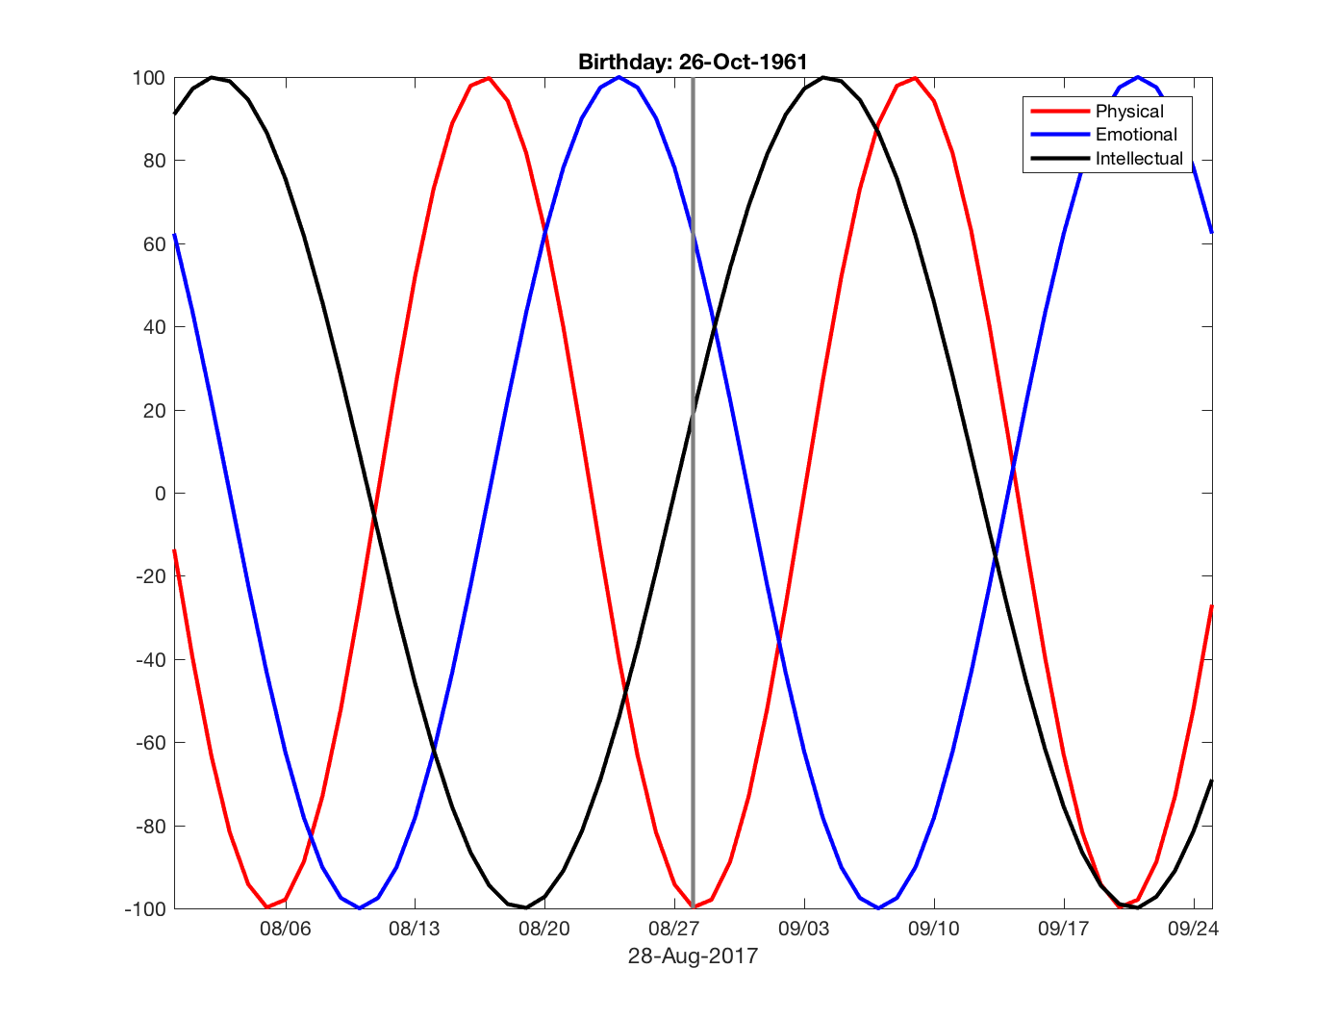

The following code segment is part of a program that plots a biorhythm for an eight-week period centered on the date August 28, 2017:

**t0 = datenum('Oct. 26, 1961');**

**t1 = datenum('Aug. 15, 2016');**

**t = (t1-28):1:(t1+28);**

**y1 = 100*sin(2*pi*(t-t0)/23);**

**y2 = 100*sin(2*pi*(t-t0)/28);**

**y3 = 100*sin(2*pi*(t-t0)/33);**

**plot(t,y1,'LineWidth',2);**

**hold on**

**plot(t,y2,'LineWidth',2);**

**plot(t,y3,'LineWidth',2);**

a) Complete the program above, using your own birthday, and the **line, datetick, title, datestr, legend**, and **xlabel** functions. Your program should produce something like the figure above.

b) The three rhythms are periodic functions, with periods 23, 28, and 33 days. There will be a day in your life when all three rhythms will be zero again (“resetting” the rhythms): it will occur 23*28*33 days after your birth, i.e. on day 21252, i.e. when you will be 58 years old! Can you find which day this will be?

c) In between your birthdate and that day, is there a day where all your 3 biorhythms will be maximum? The answer is no…. but can you find a “near perfect” day, i.e. a day where the three biorhythms will be close to 1?

- Consider finding the maximum of the sum of the three functions y1, y2, and y3