ECS 129

Project #2

Due: Tuesday, February 13 2024

Proteins

Problem1: Visualizing the envelope of a virus.

The envelope is the protein shell of a virus. It consists of several oligomeric structural subunits made of proteins called protomers. The envelope encloses the genetic material of the virus. Viral envelopes are broadly classified according to their structure. The majority of viruses have envelopes with either helical or icosahedral structure. The icosahedral shape, which has 20 equilateral triangular faces, approximates a sphere, while the helical shape is cylindrical. The envelope faces may consist of one or more proteins. For example, the zika virus envelope has faces consisting of three copies of one protein, the envelope protein, or E protein. The structure of the full zika virus has been determined by cryo-EM; the corresponding PDB ID is 5iz7. Based on this structure:
- Generate an image of a dimer of the E protein (see image below). Information on the domains of the protein can be found in the paper associated with the PDB structure 5iz7 (figure 2c)
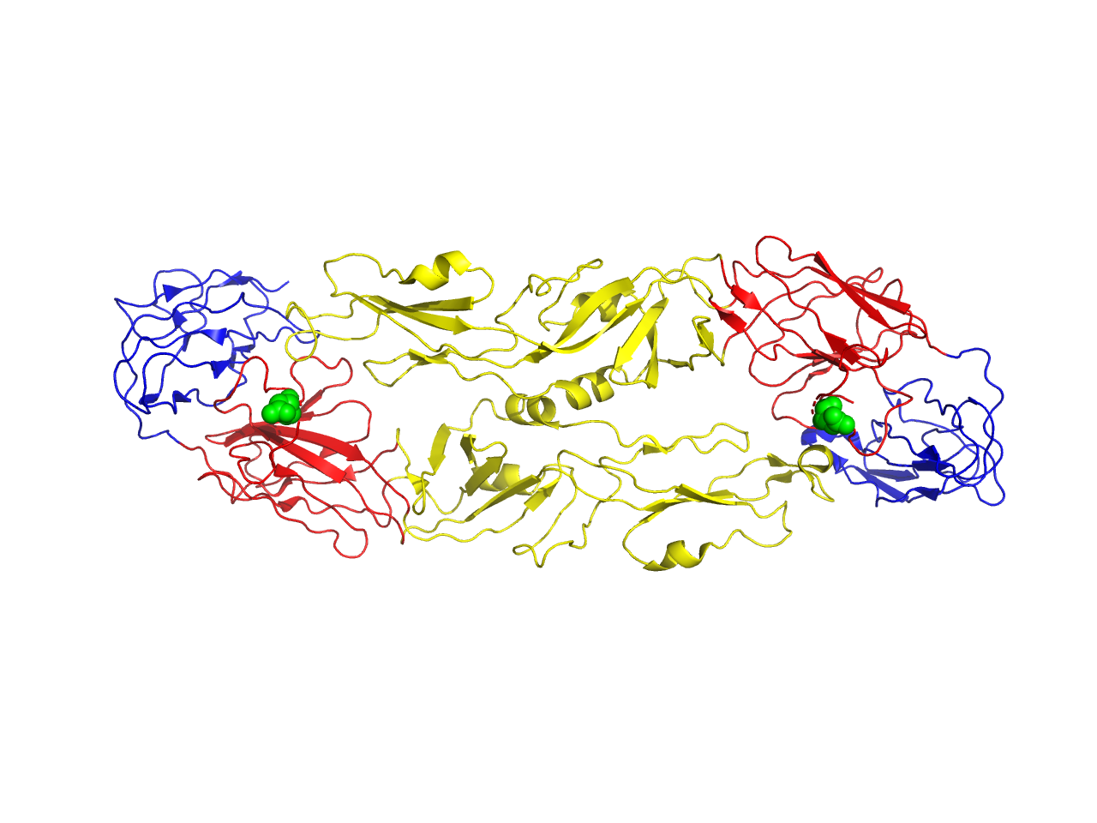

- Generate an image of the full envelope of the zika virus

Problem 2: Identification of a disease
A short fragment of a protein has been identified as a marker for a human genetic disease. This fragment is:
GLASLGTPDEYIEKLAT

- Identify the wildtype human protein associated with this fragment.
(Blast can be run at: https://blast.ncbi.nlm.nih.gov/Blast.cgi?PAGE=Proteins )
- Obtain the one letter AA code sequence of the full wildtype protein.
- Describe the single mutation between the wildtype sequence and the marker given above.
- A structure exists for the mutant protein identified with the marker (1TDW). Generate an image of the structure of this protein, with the protein in cartoon mode and the mutated residue represented as spheres.
- This mutation has been associated with an inherited disorder. Find the name of that disorder, and write a small paragraph on the nature, and consequences of this disease.

Good Luck !

