ECS 15: Introduction to Computers
Midterm
November 2nd, 2011

Notes:
- The midterm is open book, open notes.
- You have 50 minutes, no more: I will strictly enforce this.
- The midterm is divided into 2 parts, and graded over 120 points
- You can answer directly on these sheets (preferred), or on loose paper.
- Please write your name at the top right of each page you turn in!
- Please, check your work! If possible, show your work when multiple steps are involved.

Part I (15 questions, each 4 points; total 60 points)
(These questions are multiple choices; in each case, find the most plausible answer)

- When your computer slows down significantly, it is likely that you may be …
  - Running out of ROM,
  - Running out of RAM,
  - Running out of disk space,
  - Have too much ROM.

- How many bytes are there in one Megabyte (MB)?
  - 1,000,000
  - 1,000,024
  - 1,048,576
  - 1,024,000

- If an 8-bit integer has a maximum of 256 possible values, what is the highest possible value of a 16-bit integer?
  - 512
  - 65536
  - 65535
  - 32767

- How much space would you need to store a 10 min song that has been sampled at 44.1 KHz, with each data point stored on 16 bits, in stereo (assume no compression)?
  - About 100 MBytes
  - About 100 Mbits
  - About 50 Mbytes
  - About 5 Mbytes
- If your computer starts thrashing, it is likely that:
  - The CPU starts overheating,
  - The hard drive starts failing,
  - You have too many applications opened simultaneously,
  - You have been disconnected from the Internet.

- Assuming that there are 600,000 characters in the UNICODE, what is the minimal number of bits needed to store a word of ten characters with this code?
  - 19
  - 20
  - 200
  - 10

- If a computer fails the POST, it is likely that:
  - The operating system has crashed,
  - One application is using more memory than it has asked for,
  - The Master Boot Record is empty,
  - One piece of hardware attached to the computer has failed.

- Which of the following retains its information when the computer is turned off?
      - ROM
      - CPU
      - RAM
      - GPU

- The binary representation of the hexadecimal 7F is
- 01111110
- 10111111
- 01111111
- 11111111

- On a 16 bit color display, each pixel can be represented with how many different colors?
  - 16
  - 256
  - 65536
  - 32768

- To run several programs apparently simultaneously on a computer, you need:
      - As many CPU or computing cores as programs that you want to run simultaneously
      - An operating system that allows multi-threading
      - An operating system that allows multi-tasking
      - A super-computer; no personal computers or laptops can run several programs apparently simultaneously.

- Let A be the binary number 1100110 and B the binary number 11100010; which of these binary numbers C satisfies A+C = B?
  - 11111111
  - 111
  - 1000000
  - 1111100

- What is the first step of a CPU cycle?
      - Fetch the instruction,
      - Clear the memory,
      - Execute the instruction,
      - Mix water and detergent.

- Hummingbirds are birds that can flap their wings up to 90 times a second. What is the most appropriate sampling rate to use if you want to monitor the flight of a hummingbird correctly with a digital device?
      - 1 Hz,
      - 10 Hz,
      - 100 Hz,
      - 200 Hz.

- Interpreters and compilers are:
- Word processing applications,
- Tests included in the POST,
- Programs that translate a source code written in a high-level language into machine language,
- Drivers for printers.

Part II (three problems, 20 points each; total 60 points)

1) Different types of digital clocks: what time is it on the two clocks shown below?
A) B)

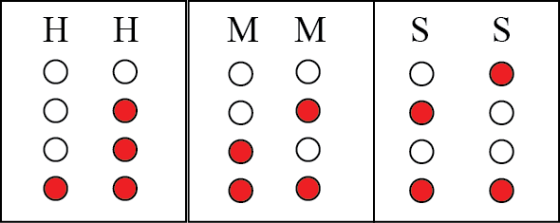

17 hours 35 minutes 59 seconds

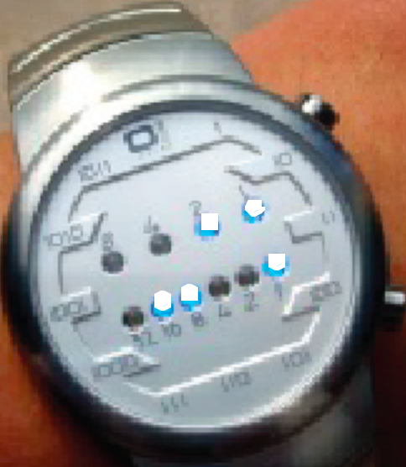
(white dots are “on”)
3 hours 25 minutes
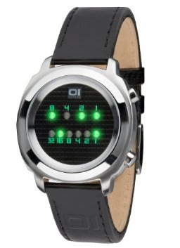

2) Look carefully at the logical circuit below, and complete the table. Remember: an input of 0 means no current, while an input of one means current is on.
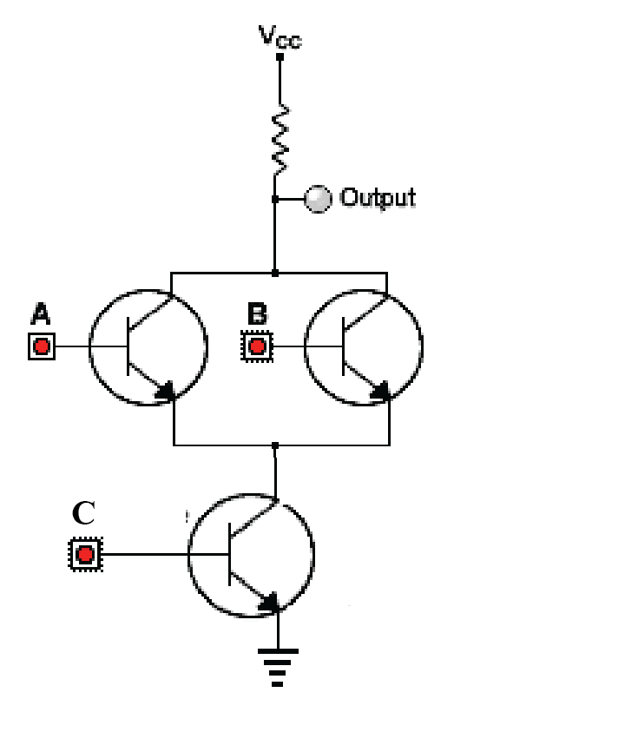

Input A | Input B | Input C | Output
1 | 1 | 1 | 0
1 | 1 | 0 | 1
1 | 0 | 1 | 0
1 | 0 | 0 | 1
0 | 1 | 1 | 0
0 | 1 | 0 | 1
0 | 0 | 1 | 1
0 | 0 | 0 | 1

3) The table below lists on the left four devices that can be found inside a computer. For each of these devices, give their purpose (center column), and list in the right column what could happen if they would stop working.

Device | Purpose | Possible problem
Heat sink | Cools down the CPU | If heat sink is broken, CPU may overheat
Power supply | Provides power to all devices in the computer | Computer will not work at all
BIOS EPROM chip | Chip on which the BIOS is stored | If BIOS chip is defective, the BIOS will not run and the computer will not start
North bridge | Serves as a connector to the main buses in the computer (those corresponding to the CPU, memory, graphics card,…) | If defective, the CPU, memory, graphics card will not be connected anymore: the computer will stop working.

