ECS 15: Introduction to Computers
Midterm
November 2nd, 2012

Notes:
- The midterm is open book, open notes.
- You have 50 minutes, no more: I will strictly enforce this.
- The midterm is divided into 2 parts, and graded over 100 points
- You can answer directly on these sheets (preferred), or on loose paper.
- Please write your name at the top right of each page you turn in!
- Please, check your work! If possible, show your work when multiple steps are involved.

Part I (15 questions, each 4 points; total 60 points)
(These questions are multiple choices; in each case, find the most plausible answer)

- Your computer does not turn on when you press the ON button; it does not even run through the BIOS. The most likely reason for this failure is …
  - You did not connect your computer to a power supply (or your battery is empty),
  - The CPU has failed,
  - Your hard drive is full,
  - The video card is missing.

- How many bytes can you transfer through a 32 bit bus at 1GHz during 1 millisecond?
  - 4,000,000
  - 32,000,000
  - 4,000,000,000
  - 8,000,000

- If a 4-bit integer has a maximum of 16 possible values, what is the highest possible value of a 8-bit integer?
  - 512
  - 256
  - 255
  - 511

- How much space would you need to store a 6 min song that has been sampled at 44.1 KHz, with each data point stored on 16 bits, in stereo (assume no compression)?
  - About 60 MBytes
  - About 60 Mbits
  - About 30 Mbytes
  - About 6 Mbytes

- If the BIOS stops at the POST, it is possible that:
  - You forgot to turn on the computer,
  - Your video card is not functioning,
  - You have too many applications opened simultaneously,
  - You have been disconnected from the Internet.

- If the Master Boot Record is corrupted,
  - The BIOS cannot start the operating system
  - The BIOS cannot initialize the hard drive
  - The operating system cannot find a graphical interface
  - The computer has a high risk of overheating

- Let A be the hexadecimal number F1 and B the hexadecimal number 101; which of these hexadecimal numbers C satisfies A+C = B?
  - A0,
  - 10,
  - 11,
  - 1F2

- Which of these 4 numbers, given in hexadecimal format, correspond to green in the RGB system?
      - #FFFFFF
      - #FF00FF
      - #00FFFF
      - #00FF00

- The binary representation of the hexadecimal 3D is
- 00111110
- 00111101
- 01111110
- 01111101

- On an 8-bit color display, each pixel can be represented with how many different colors?
  - 16
  - 256
  - 65536
  - 32768

- Assume that the UNICODE contains 250,000 characters. What is the minimal number of bits needed to store the character with the largest binary representation?
      - 16
      - 17
      - 18
      - 8

- Let A be the binary number 1010 and B the binary number 11011; which of these binary numbers C satisfies A+C = B?
  - 11111
  - 11001
  - 10101
  - 10001

- Multiplying two numbers on a computer requires 20 cycles of computing time. How long would it take to perform a calculation that involves 5 million multiplications on a 2GHz processor?
      - 0.5s,
      - 0.05s,
      - 0.005s,
      - 0.0005s.

- A new type of binary-encoded clock is introduced and work as described below:

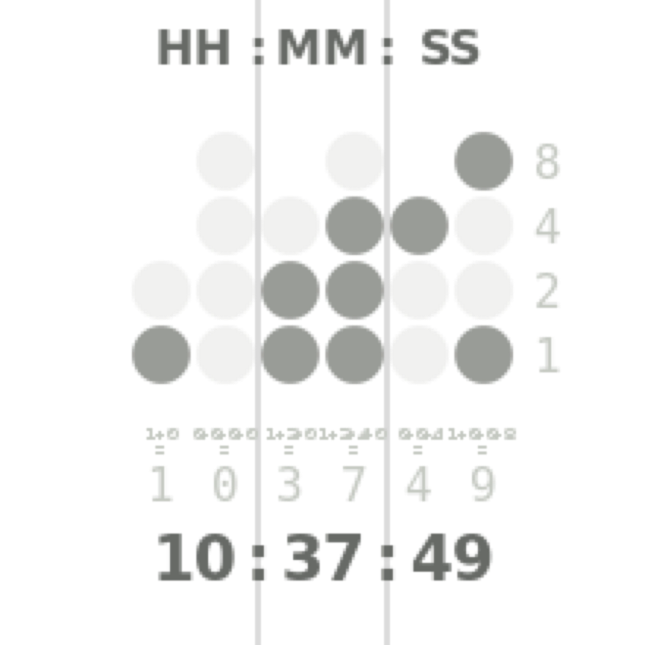
Add the values of each column to get six decimal digits. There are two columns each for hours, minutes and seconds.
In the example shown:
Hours: 1 in the left column
0 in the right column
Therefore: 10 hours
Minutes: 3 (1+2) in the left column
7 (1+2+4) in the right column
Therefore: 37 minutes
Seconds: 4 in the left column
9 (8+1) in the right column
Therefore: 49 seconds.

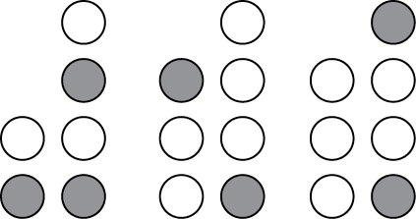
What time is it on this clock?

- 13:41:10
- 13:41:09
- 15:41:08
- 15:41:09

- Mannikins are birds that can flap their wings up to 100 times a second. Which of these sampling rates is most appropriate to use if you want to monitor the flight of a mannikin correctly with a digital device?
      - 3 Hz,
      - 30 Hz,
      - 300 Hz,
      - 100 Hz.

Part II (four problems; total 40 points)

1) Based on the logic tables for the two basic gates AND and OR given below, find the logic table associated with the “new” gate X: (20 points)

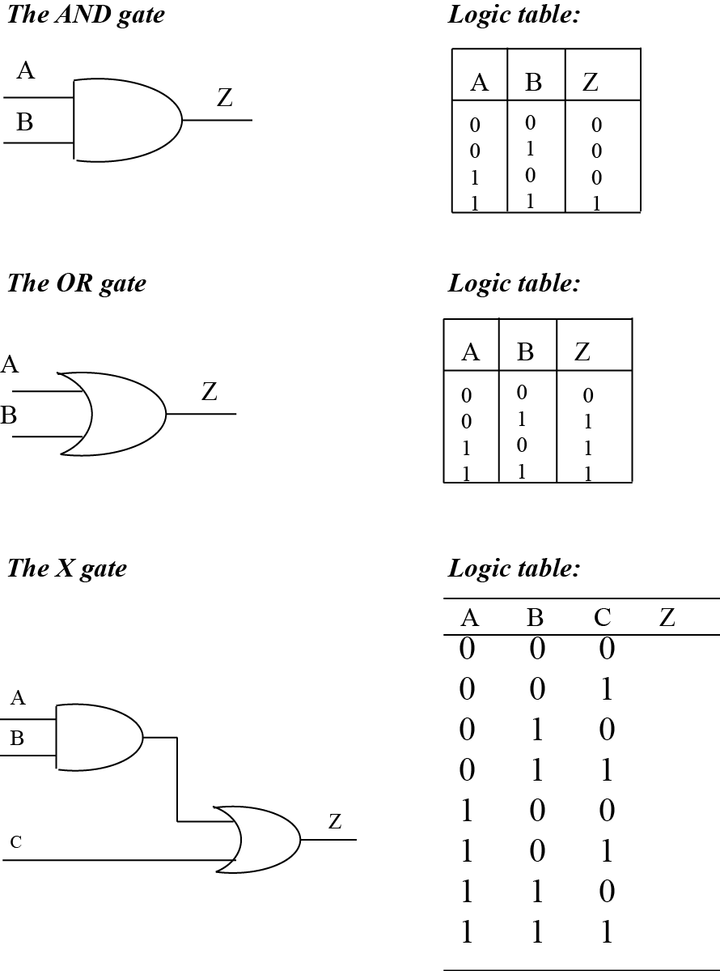
2) Look carefully at the code for a small HTML document below. There are five mistakes that were inserted in this code. Please identify them (and briefly explain them) (10 points)

<html>

<head>
<title>My page
</head>

<body>
<p> Some useful links: </p>
<ul>
<li> <a href=“http://www.ucdavis.edu”>UC Davis </a> </li>
<li> <a “http://www.google.com”> Google search </a> </li>
<li> <a href=“http://smartsite.ucdavis.edu”>UC Davis Smartsite </a>
</p>
</body

Errors:

1)

2)

3)

4)

5)

3) The London philharmonic orchestra comes to give a concert at the Mondavi Center on campus and you are in charge of its digital recording. The concert lasts 2 hours. To guarantee a high quality recording, 8 microphones are placed in the room. The signal recorded by each microphone is sampled at 44.1 KHz and each sample is stored on 24 bits. How much space (in Mbytes) will you need to store the whole concert, assuming no compression. (5 points)

4) List at least 5 devices that can be used to input information to a computer (5 points).

