ECS 15: Introduction to Computers
Midterm: Solutions
November 2nd, 2012

Notes:
- The midterm is open book, open notes.
- You have 50 minutes, no more: I will strictly enforce this.
- The midterm is divided into 2 parts, and graded over 100 points
- You can answer directly on these sheets (preferred), or on loose paper.
- Please write your name at the top right of each page you turn in!
- Please, check your work! If possible, show your work when multiple steps are involved.

Part I (15 questions, each 4 points; total 60 points)
(These questions are multiple choices; in each case, find the most plausible answer)

- Your computer does not turn on when you press the ON button; it does not even run through the BIOS. The most likely reason for this failure is …
  - You did not connect your computer to a power supply (or your battery is empty),
  - The CPU has failed,
  - Your hard drive is full,
  - The video card is missing.
If the computer does not turn on at all, it is not connected to a power supply.

- How many bytes can you transfer through a 32 bit bus at 1GHz during 1 millisecond?
  - 4,000,000
  - 32,000,000
  - 4,000,000,000
  - 8,000,000
A 32 bit bus transfers 4 bytes every cycle. There are 1,000,000,000 cycles per second, or 1,000,000 cycles per millisecond. Therefore you can transfer 4,000,000 bytes per millisecond

- If a 4-bit integer has a maximum of 16 possible values, what is the highest possible value of a 8-bit integer?
  - 512
  - 256
  - 255
  - 511
The range of values that can be stored on 8 bits is 0-255 (i.e. you can store 256 different values, but the largest one is 255).
- How much space would you need to store a 6 min song that has been sampled at 44.1 KHz, with each data point stored on 16 bits, in stereo (assume no compression)?
  - About 60 MBytes
  - About 60 Mbits
  - About 30 Mbytes
  - About 6 Mbytes
6 (min) x 60 (seconds/min) x 44,100 (points/second) x 2 (16bits=2bytes) x 2 (stereo) is approximately 60 Mbytes (remember, approximately 10 MB per minute)

- If the BIOS stops at the POST, it is possible that:
  - You forgot to turn on the computer,
  - Your video card is not functioning,
  - You have too many applications opened simultaneously,
  - You have been disconnected from the Internet.
POST checks hardware.

- If the Master Boot Record is corrupted,
  - The BIOS cannot start the operating system
  - The BIOS cannot initialize the hard drive
  - The operating system cannot find a graphical interface
  - The computer has a high risk of overheating
The Master Boot Record indicates where the operating system is.

- Let A be the hexadecimal number F1 and B the hexadecimal number 101; which of these hexadecimal numbers C satisfies A+C = B?
  - A0,
  - 10,
  - 11,
  - 1F2
A = #F1 = 15x16+1 = 241 (in decimal)
B = #101 = 1x16^2 + 0x16 + 1 = 257 (in decimal)
Therefore C = 257 – 241 = 16 = #10

- Which of these 4 numbers, given in hexadecimal format, correspond to green in the RGB system?
      - #FFFFFF
      - #FF00FF
      - #00FFFF
      - #00FF00
In the RGB system, a number of the form #XXYYZZ indicates XX amount of Red, YY amount of Green, and ZZ amount of Blue (where XX, YY, ZZ are given in hexadecimal). We want XX and ZZ to be zero (only green), therefore the solution is d.

- The binary representation of the hexadecimal 3D is
- 00111110
- 00111101
- 01111110
- 01111101
3D
3 D
0011 1101 (see table)
00111101

- On an 8-bit color display, each pixel can be represented with how many different colors?
  - 16
  - 256
  - 65536
  - 32768
8 bits can store 256 different values (see question 3)

- Assume that the UNICODE contains 250,000 characters. What is the minimal number of bits needed to store the character with the largest binary representation?
      - 16
      - 17
      - 18
      - 8
The largest character to store has index 250,000. With 17 bits, the largest number is 2^17-1= 131071; i.e. 17 bits are not enough. With 18 bits, the largest number is 2^18-1 = 262143, i.e. large enough.

- Let A be the binary number 1010 and B the binary number 11011; which of these binary numbers C satisfies A+C = B?
  - 11111
  - 11001
  - 10101
  - 10001
A = 1010 (binary) = 10 (decimal)
B = 11011 (binary) = 27 (decimal)
Therefore C = 17 (decimal) = 10001 (binary)

- Multiplying two numbers on a computer requires 20 cycles of computing time. How long would it take to perform a calculation that involves 5 million multiplications on a 2GHz processor?
      - 0.5s,
      - 0.05s,
      - 0.005s,
      - 0.0005s.

5 million multiplications require 100 million cycles. In one second, the computer can perform 2,000 million cycles. Therefore we need 1/20 second = 0.05 second.

- A new type of binary-encoded clock is introduced and work as described below:

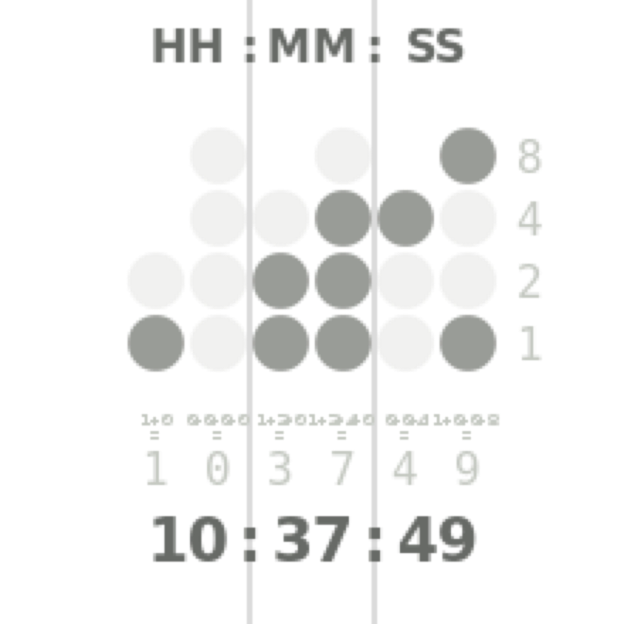
Add the values of each column to get six decimal digits. There are two columns each for hours, minutes and seconds.
In the example shown:
Hours: 1 in the left column
0 in the right column
Therefore: 10 hours
Minutes: 3 (1+2) in the left column
7 (1+2+4) in the right column
Therefore: 37 minutes
Seconds: 4 in the left column
9 (8+1) in the right column
Therefore: 49 seconds.

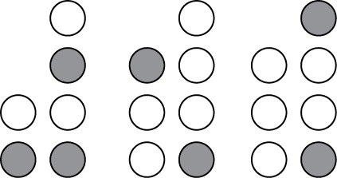
What time is it on this clock?

- 13:41:10
- 13:41:09
- 15:41:08
- 15:41:09

- Mannikins are birds that can flap their wings up to 100 times a second. Which of these sampling rates is most appropriate to use if you want to monitor the flight of a mannikin correctly with a digital device?
      - 3 Hz,
      - 30 Hz,
      - 300 Hz,
      - 100 Hz.
The flapping has a frequency of 100 Hz. We need to sample it at at least twice this frequency; 300 Hz is the only possible answer.

Part II (four problems; total 40 points)

1) Based on the logic tables for the two basic gates AND and OR given below, find the logic table associated with the “new” gate X: (20 points)

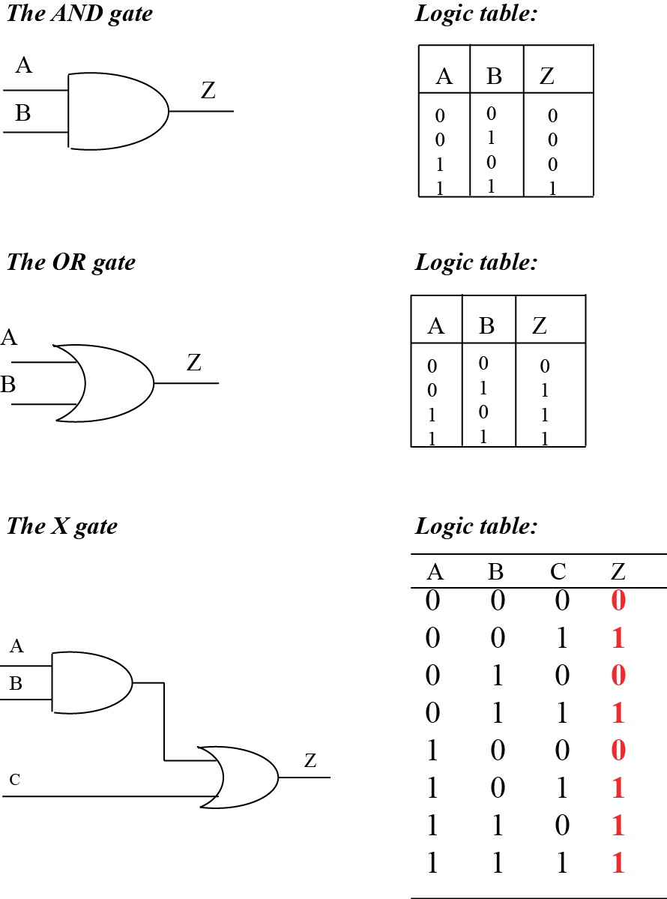
2) Look carefully at the code for a small HTML document below. There are five mistakes that were inserted in this code. Please identify them (and briefly explain them) (10 points)

<html>

<head>
<title>My page </title>
</head>

<body>
<p> Some useful links: </p>
<ul>
<li> <a href=“http://www.ucdavis.edu”>UC Davis </a> </li>
<li> <a href=“http://www.google.com”> Google search </a> </li>
<li> <a href=“http://smartsite.ucdavis.edu”>UC Davis Smartsite </a> </li>
</ul>
</body>
</html>

Errors:

1) <title> needs to be closed with </title>

2) missing href=

3) missing </li> for third list item

4) </body should be </body>

5) missing </html>

6) </p> should be </ul>

3) The London philharmonic orchestra comes to give a concert at the Mondavi Center on campus and you are in charge of its digital recording. The concert lasts 2 hours. To guarantee a high quality recording, 8 microphones are placed in the room. The signal recorded by each microphone is sampled at 44.1 KHz and each sample is stored on 24 bits. How much space (in Mbytes) will you need to store the whole concert, assuming no compression. (5 points)

2 (hours) x 60 (mins/hour) x 60 (second/hour) x 44,100 (sample/second) x 3 (byte/sample) x 8 (microphones)

= 7,620.48 Mbytes = 7.62 GB

4) List at least 5 devices that can be used to input information to a computer (5 points).

For example: Keyboard
Mouse
Tactile screen
Microphone
camera

