**ECS 17: Data, Logic, and Computing**

**Midterm 1**

**February 7, 2024**

***Notes:***

1. The midterm is open book, open notes.
2. You have 50 minutes, no more: I will strictly enforce this.
3. The midterm is graded over 70 points
4. You can answer directly on these sheets (preferred), or on loose paper.
5. Please write your name at the top right of each page you turn in!
6. Please, check your work! **Also, do show your work**

**Part I (6 questions, each 5 points; total 30 points)**

(These questions are multiple choices; in each case, find the most **plausible** answer)

1. ***The binary equivalent of the hexadecimal number #1A3 is:***
   1. (11010011)2
   2. (110100011)2
   3. (1001010011)2
   4. (11010)2

|  |  |
| --- | --- |
| Initial Hexadecimal number: | 1A3 |
| Split hexadecimal number: | 1 A 3 |
| 4-digit binary groups: | 0001 1010 0011 |
| Regrouped binary: | 000110100011 |
| Binary number: | 110100011 |

1. ***Let A be the number with the hexadecimal representation #C and B the number whose hexadecimal representation is #24; which of these numbers X (in hexadecimal form) satisfies X2 – AX + B = 0?*** 
   1. #A
   2. #B
   3. #6
   4. #7

#C equals 12 in decimal. #24 equals 36 in decimal. The equation is then

*X2 – 12X + 36 = 0*, whose (unique) solution is 6, with the hexadecimal representation #6.

1. ***You want to store a silent movie on your computer. You know that your movie is 2 hour long, that it was filmed at a rate of 25 frames per second and that you need 10 kilobytes to store each frame. How much space to you need to store the whole movie, in megabytes (assuming that 1 megabyte = 1000 kilobytes)?***
   1. 1.8 megabytes
   2. 1,800 megabytes (=1.8 GB)
   3. 180,000 megabytes (=180 GB)
   4. 36,000 megabytes (=3.6 GB)

The movie is silent, so we only need to worry about the images:

Space = 2 [hours] x 3600 [second]/[hour] x 25 [frames]/[second] x 10 [kBytes]/frames]

Space = 1,800,000 kBytes

Space = 1,800 MegaBytes (using the approximation that 1 megabyte = 1000 kilobytes)

1. ***A heart monitor works with a sampling frequency of 6 Hz. Which of these animals can be correctly monitored when resting, given the ranges of their resting heart rates (circle all that apply)***
   * + 1. Dog: 70-120 beats per minute,
       2. Elephant: 25-35 beats per minute,
       3. Chicken: 250-300 beats per minute,
       4. Hamster: 300-600 beats per minute.

The heart monitor works with a frequency of 6Hz, which is equivalent to 360 beats / minutes. Based on the Nyquist theorem, the highest resting heart rate that can be monitored is half of this, i.e. 180 beats / minutes. Only the dog and elephant would then be correctly monitored.

1. ***If we sum the ASCII codes of the letters in a 2-letter word we get the hexadecimal #96. Which of those words would satisfy this property (circle all that are correct)?***
   * + 1. AS: A is 65 (decimal), S is 83 (decimal); sum = 146 (decimal) = #92
       2. BT: B is 66 (decimal), T is 84 (decimal); sum = 150 (decimal) = #96
       3. ECS: 3-letter word!!
       4. CS: C is 67 (decimal), S is 83 (decimal); sum = 150 (decimal) = #96
2. ***The gate shown below is equivalent to:***

* 1. The NAND gate,
  2. The AND gate,
  3. The OR gate, (see homework 4)
  4. The NOR gate.

**Part II (two problems, each 10 points; total 20 points)**

1. Complete the logic table corresponding to the logic gate shown below. Convert it into a Boolean expression ***(10 points)***

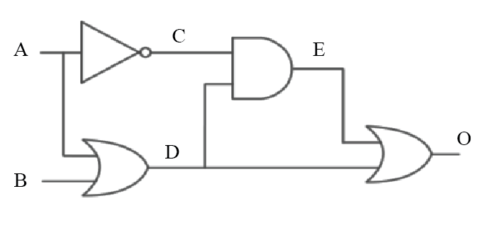

|  |  |  |  |  |  |
| --- | --- | --- | --- | --- | --- |
| **A** | **B** | **C** | **D** | **E** | **O** |
| 1 | 1 | 0 | 1 | 0 | 1 |
| 1 | 0 | 0 | 1 | 0 | 1 |
| 0 | 1 | 1 | 1 | 1 | 1 |
| 0 | 0 | 1 | 0 | 0 | 0 |

$$O=E+D=C⋅D+D=\overline{A}⋅\left(A+B\right)+\left(A+B\right)$$

This is in fact the OR gate!

2) An engineer hands you a piece of paper with the following Boolean expression on it, and tells you to build a gate circuit to perform that function:

$$A⋅B + \overline{A}⋅\overline{B}$$

Draw a logic gate circuit for this function Represent its table of truth. Can you find a simpler logic gate that would perform the same operation? ***(10 points)***

|  |  |  |  |  |  |
| --- | --- | --- | --- | --- | --- |
| **A** | **B** | **C** | **D** | **O** |  |
| 1 | 1 | 1 | 0 | 1 | 1 |
| 1 | 0 | 0 | 0 | 0 | 1 |
| 0 | 1 | 0 | 0 | 0 | 1 |
| 0 | 0 | 0 | 1 | 1 | 0 |

This is in fact the XNOR gate!

**Part III (two problems, each 10 points; total 20 points)**

1) Two guards are standing outside the entrance to a cave, guarding the treasure within. The treasure is one of copper, silver, gold, platinum, diamonds, or rubies. **Guard 1** lies when guarding **copper**, **silver**, or **gold** and tells the truth when guarding other treasure. **Guard 2**, on the other hand, lies when guarding **platinum**, **diamonds**, or **rubies**, but tells the truth when guarding other treasure.

You meet the guards at the entrance to the treasure cave, and they make these statements:

* Guard 1 says: **The treasure is either gold or copper**.
* Guard 2 says: **I hate chocolate**.

If you determine the content of the cave, the guards will let you pass and you can claim the treasure. Will you be able to? In addition, does guard 2 really hate chocolate? Show your work (***10 points***)

We build a truth table:

|  |  |  |
| --- | --- | --- |
| Line # | Inside the cave | Guard 1 says |
| 1 | Copper | True |
| 2 | Silver | False |
| 3 | Gold | True |
| 4 | Platinum | False |
| 5 | Diamonds | False |
| 6 | Rubies | False |

Line 1 is incompatible: the cave contains copper, guard1 should lie but they tell the truth.

Line 2 is compatible: the cave contains silver; Guard 1 lies and guard 2 tells the truth.

Line 3 is incompatible: the cave contains gold, guard1 should lie but they tell the truth.

Line 4 is incompatible: the cave contains platinum, guard1 should tell the truth but they lie.

Line 5 is incompatible: the cave contains diamonds, guard1 should tell the truth but they lie.

Line 6 is incompatible: the cave contains rubies, guard1 should tell the truth but they lie.

Therefore, only line 2 is compatible: the cave contains a treasure of silver. As guard 2 is telling the truth when the cave contains silver, they really hate chocolate.

2) In the strange community of Subterranea, visitors cannot tell day from night, but the residents can. The residents are of two types: day-knights or night-knights. Day-knights tell the truth during the day and lie at night, while night-knights tell the truth at night and lie during the day.

Suppose you are visiting Subterranea - naturally, you lose your sense of time and would like to know whether it is day or night. You encounter two inhabitants, John and Sally, and each makes a statement:

* John says: **Sally is a day-knight, and it is day.**
* Sally says: **I am a night-knight, and John is a night-knight.**

Is it day or night now? Show your work ***(10 points)***

We build a truth table:

|  |  |  |  |  |  |
| --- | --- | --- | --- | --- | --- |
| Line # | Day / Night | John | Sally | John Says | Sally says |
| 1 | Day | Day-knight | Day-knight | True | False |
| 2 | Day | Day-knight | Night-knight | False | False |
| 3 | Day | Night-knight | Day-knight | True | False |
| 4 | Day | Night-knight | Night-knight | False | True |
| 5 | Night | Day-knight | Day-knight | False | False |
| 6 | Night | Day-knight | Night-knight | False | False |
| 7 | Night | Night-knight | Day-knight | False | False |
| 8 | Night | Night-knight | Night-knight | False | True |

Compatibility:

Line 1 is incompatible: Sally is a day-knight, it is day, she should tell the truth, but she lies.

Line 2 is incompatible: John is a day-knight, it is day, he should tell the truth, but he lies.

Line 3 is incompatible: John is a night-knight, it is day, he should lie, but he tells the truth.

Line 4 is incompatible: Sally is a night-knight, it is day, she should lie, but she tells the truth.

Line 5 is compatible: both are day-knights, it is night, so they should lie, which they do.

Line 6 is incompatible: Sally is a night-knight, it is night, she should tell the truth, but she lies.

Line 7 is incompatible: John is a night-knight, it is night, he should tell the truth, but he lies.

Line 8 is incompatible: John is a night-knight, it is night, he should tell the truth, but he lies.

The only compatibility is line 5: it is nighttime, and both John and Sally are day-knights and therefore they are lying.

Appendix A: ASCII table

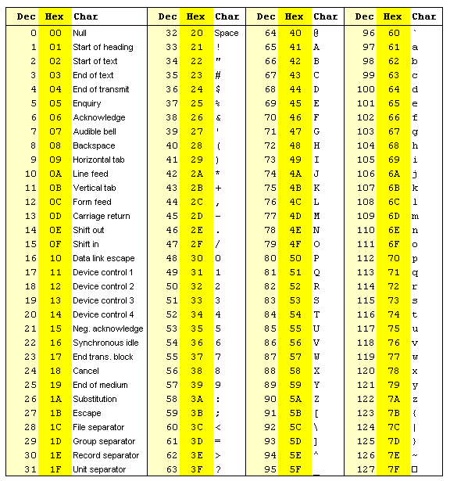

Appendix B: Binary to Hexadecimal

|  |  |  |
| --- | --- | --- |
| Base 10 | Base 2 | Base 16 |
| 0 | 0000 | 0 |
| 1 | 0001 | 1 |
| 2 | 0010 | 2 |
| 3 | 0011 | 3 |
| 4 | 0100 | 4 |
| 5 | 0101 | 5 |
| 6 | 0110 | 6 |
| 7 | 0111 | 7 |
| 8 | 1000 | 8 |
| 9 | 1001 | 9 |
| 10 | 1010 | A |
| 11 | 1011 | B |
| 12 | 1100 | C |
| 13 | 1101 | D |
| 14 | 1110 | E |
| 15 | 1111 | F |

