**ECS 17: Data, Logic, and Computing**

**Final**

**March 14, 2022**

***Notes:***

1. The final is open book, open notes.
2. You have 2 hours minutes, no more: I will strictly enforce this.
3. The final is graded over 100 points
4. You can answer directly on these sheets (preferred), or on loose paper.
5. Please write your name at the top right of each page you turn in!
6. Please, check your work! **Also, do show your work**

**Part I Data (10 questions, each 3 points; total 30 points)**

(These questions are multiple choices; in each case, find the most **plausible** answer)

1. ***CPUs in computers are covered with a heat sink to:*** 
   1. Dissipate the heat they release
   2. Make them look pretty
   3. Protect them from shocks (for example if the computer falls)
   4. Isolate them from the other devices to avoid interferences
2. ***Let A be the number with the binary representation 100 and B the number whose hexadecimal representation is 1; which of these numbers X (in hexadecimal form) satisfies BX2-AX+A=0?*** 
   1. A
   2. 1
   3. 2
   4. D
3. ***Which word is encoded in the ASCII code 01100101 01100011 01110011?***
   1. ect
   2. ess
   3. ECS
   4. ecs
4. ***A continuous-time signal is uniformly sampled over 5001 samples, for a total of 2.5 seconds. Components with which of those frequencies could be correctly detected in the sampled signal? (circle all that apply)***
   * + 1. 400 Hz,
       2. 800 Hz,
       3. 1200 Hz,
       4. 1600 Hz.
5. ***You take a picture with a digital camera, and you know that this picture requires 32 Mbytes of storage (without compression). Assuming that each pixel is stored on 32 bits, what is the resolution of your camera, in megapixels:***
   * + 1. 16
       2. 1
       3. 8
       4. 32
6. ***Which binary number comes right after the binary number 110111?***
   1. 111000
   2. 110111
   3. 111111
   4. 110112
7. ***The binary representation of the hexadecimal 95 is***
8. 1011001
9. 1011111
10. 10010101
11. 149
12. ***You want to store a movie on your computer. You know that your movie is 2 hour long. It was filmed at a rate of 25 frames per second and each frame requires 10 kilobytes of storage. The soundtrack was stored in stereo, recorded at 50KHz, with 2 bytes per point. How much space is needed to store the whole movie and its soundtrack, in megabytes (assuming that 1 megabyte = 1000 kilobytes)?***
    1. 2520 megabytes (=2.52 GB)
    2. 3240 megabytes (=3.24 GB)
    3. 1440 megabytes (=1.44 GB)
    4. 1800 megabytes (=1.8 GB)
13. ***One of these four sentences would NOT be considered as a proposition in Logic:***
14. All cats are white
15. An apple is not a fruit
16. 2+4 = 8
17. *X+2=8*
18. ***What is the largest number (unsigned integer) that can be stored on one bit?***
19. 255
20. 256
21. 128
22. 1

**Part II Logic (three problems; total 30 points)**

1) Complete the logic table corresponding to the logic gate shown below. Convert it into a Boolean expression

|  |  |  |  |  |
| --- | --- | --- | --- | --- |
| **A** | **B** | **C** | **D** | **O** |
| 1 | 1 |  |  |  |
| 1 | 0 |  |  |  |
| 0 | 1 |  |  |  |
| 0 | 0 |  |  |  |

2) A very special island is inhabited only by knights and knaves. Knights always tell the truth, and knaves always lie. You meet three inhabitants: Alex, John and Sally. Alex says, `If Sally is a knight, I am a knave.' John says, `Alex and Sally are of the same type.' Sally claims, `I like chocolate.' *(Note that “to be of the same type” means that they are both knights or they are both knaves.)* Does Sally really like chocolate? Justify your answer.

3) Let *p, q,* and *r* be three propositions. Use a truth table or logical equivalence to indicate if the proposition  is a tautology, a contradiction, or neither

**Part III. Proofs (4 questions; each 10 points; total 40 points)**

1) Let *n* be an integer. Show that *n* is even if and only if  is even.

2) Let *a* and *b* be two integers. Show that *a2-4b ≠3 (hint: you may assume true the fact that when n is an integer, if n2 is odd, then n is odd).*

3) Show by induction that  for all n≥1

3) Let be the sequence defined by $a_{k}=a_{k-1}+k+4$ for *k≥2*, with $a_{1}=5$. Show by induction that 

**Part IV. Counting (Extra credit:** 5 points**)**

How many bitstrings of length *n*>2 can we form that contain at least one 0 and at least one 1?

Appendix A: ASCII table

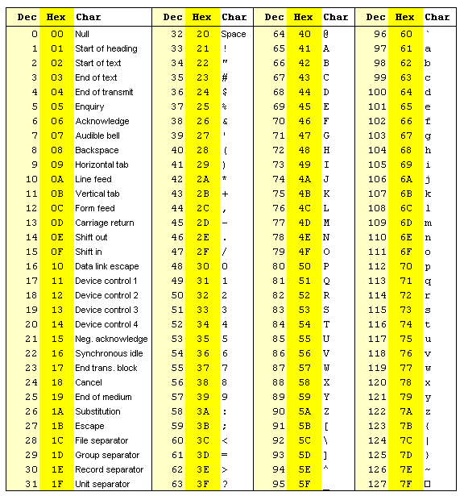

Appendix B: Binary to Hexadecimal

|  |  |  |
| --- | --- | --- |
| Base 10 | Base 2 | Base 16 |
| 0 | 0000 | 0 |
| 1 | 0001 | 1 |
| 2 | 0010 | 2 |
| 3 | 0011 | 3 |
| 4 | 0100 | 4 |
| 5 | 0101 | 5 |
| 6 | 0110 | 6 |
| 7 | 0111 | 7 |
| 8 | 1000 | 8 |
| 9 | 1001 | 9 |
| 10 | 1010 | A |
| 11 | 1011 | B |
| 12 | 1100 | C |
| 13 | 1101 | D |
| 14 | 1110 | E |
| 15 | 1111 | F |