ECS 17: Data, Logic, and Computing
Final
March 20, 2023

Notes:
- The final is open book, open notes.
- You have 2 hours, no more: I will strictly enforce this.
- The final is graded over 100 points
- Please, check your work! Also, do show your work

Part I Data (10 questions, each 3 points; total 30 points)
(These questions are multiple choices; in each case, find the most plausible answer)

- What is the largest unsigned integer that can be stored on 2 bytes?
  - 256
  - 255
  - 65535
  - 65536

- Convert the binary number (1101101111110101)₂ to hexadecimal
  - #DBF5
  - #DCF5
  - #5FBD
  - #5FCD

- (1110)₂ –(101)₂ =
  - #B
  - #8
  - #A
  - #9

- Which of these sampling rates would be appropriate for a sound sample of maximum frequency 16 kHz (circle all that apply)?
      - 16000 Hz,
      - 8000 Hz,
      - 35000 Hz,
      - 35 Hz.

- Assume that you have taken a square picture with a 4 megapixel digital camera. Assume that you are printing this picture out on a printer that has approximately 4000 dots per inch. How big would the picture be? (note: 1 dot = 1 pixel)
      - 1 inch x 1inch
      - 2 inches x 2 inches
      - 0.5 inch x 0.5 inch
      - 4 inches x 4 inches

- Which binary number comes right after the binary number 101?
  - 1100
  - 111
  - 102
  - 110

- Decode the name whose ASCII representation is #53 #61 #6C #6C #79
- Sally
- Sylla
- SALLY
- SYLLA

- The highest frequency note for a piano is fc=4200 Hz. Assuming that you record 1 hour of piano music with a sampling rate 3 times fc, in mono, with 16 bits resolution, what is the size of the resulting file (assuming 1MB = 1,000,000 bytes):
  - 0.9072 MB
  - 90.72 MB
  - 9.072 MB
  - 181.44 MB

- What time is it on this digital clock (filled circle mean “on”)?
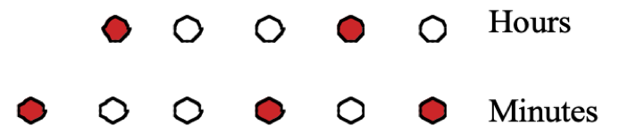

- 10:37
- 10:41
- 18:37
- 18:41

- You want to store an electronic copy of a book on your computer. This book contains 500 pages; each page contains (on average) 60 lines, and each line contains 60 characters (again, on average), including space. Each character needs 2 bytes of storage. How much space do you need to store this book (assuming 1MB = 1,000,000 bytes)?
- 3.6 MB
- 36 MB
- 0.36MB
- 360 MB

Part II Logic (three problems; total 30 points)

1) For each of the five propositions in the table below, indicates on the right if they are always tautologies or not (p and q are propositions) (10 points).

Proposition | Tautology (Yes or No)
If 2+6 = 5 then 10 = -9
$$\left(p∨¬p\right)→q$$
$$\left(p∧¬q\right)→p$$
if 3+3 = 6 then 25=16+9
$$\left(p∧¬p\right)∨\left(¬p∨p\right)$$

2) A very special island is inhabited only by knights and knaves. Knights always tell the truth, and knaves always lie. You go to this island, as you have been told that a treasure may be buried on it. You meet two inhabitants, John, and Sally. John tells you that, `I am a knight if and only if the treasure is on the island.' Sally tells you that `If John is a knight, then the treasure is not on the island.’ Can it be determined if the treasure is on the island? Can it be determined also whether John is a knight or knave? What about Sally ? Justify your answers. (10 points)

3) Let p and q be two propositions. Use a truth table or logical equivalence to show that the proposition $\left[¬\left(p→¬q\right)\right]→\left[¬\left(p↔¬q\right)\right]$is a tautology. (10 points)

Part III. Proofs (4 questions; each 10 points; total 40 points)

1) Give a direct proof and a proof by contradiction of the proposition: if 2n³ + 3n²+4n+3 is odd, then n is even, where n is a natural number.

2) Use induction to prove that any postage value of n cents can be made with only 5-cent stamps and 6-cent stamps, whenever $n≥20$, n natural number.

3) Show by induction that for all natural numbers n≥1
$$\sum_{i=1}^{n}{{\left(-1\right)}^{i}i^{2}=\frac{{\left(-1\right)}^{n}n\left(n+1\right)}{2}}$$

4) Let f_{n} be the n-th Fibonacci number (note: Fibonacci numbers satisfy f₀=0, f₁=1 and ). Prove by induction that for all natural numbers $n≥3$,
$$\frac{f_{1}}{f_{2}f_{3}}+\frac{f_{2}}{f_{3}f_{4}}+⋯+\frac{f_{n-2}}{f_{n-1}f_{n}}=1-\frac{1}{f_{n}}$$

Appendix A: ASCII table

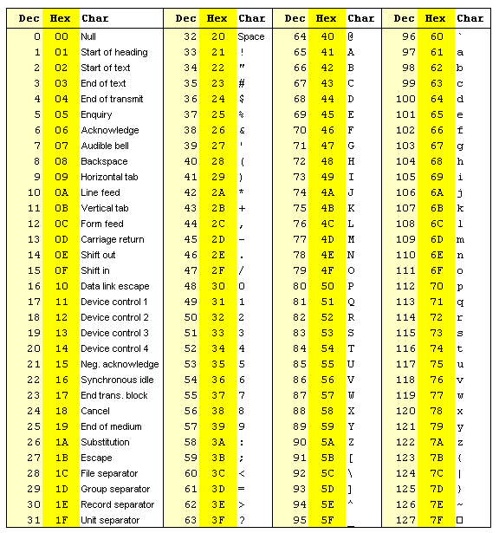

Appendix B: Binary to Hexadecimal

Base 10 | Base 2 | Base 16
0 | 0000 | 0
1 | 0001 | 1
2 | 0010 | 2
3 | 0011 | 3
4 | 0100 | 4
5 | 0101 | 5
6 | 0110 | 6
7 | 0111 | 7
8 | 1000 | 8
9 | 1001 | 9
10 | 1010 | A
11 | 1011 | B
12 | 1100 | C
13 | 1101 | D
14 | 1110 | E
15 | 1111 | F

Appendix C

