ECS 17: Data, Logic, and Computing
Midterm 1
February 2, 2022

Notes:
- The midterm is open book, open notes.
- You have 50 minutes, no more: I will strictly enforce this.
- The midterm is graded over 70 points
- You can answer directly on these sheets (preferred), or on loose paper.
- Please write your name at the top right of each page you turn in!
- Please, check your work! Also, do show your work

Part I (6 questions, each 5 points; total 30 points)
(These questions are multiple choices; in each case, find the most plausible answer)

- How much space would you need to store a 5 min song that has been sampled at 44.1 kHz, with each data point stored on 24 bits, in mono (i.e. with a single microphone)? Assume no compression.
  - About 40 Gbytes
  - About 40 Mbytes
  - About 53 Mbytes
  - About 400 Kbytes

- Let X be the number with the hexadecimal representation AA and Y the number whose hexadecimal representation is 9D; which of these numbers T (in hexadecimal form) satisfies X-T=Y?
  - A
  - B
  - C
  - D

- Which of these bytes represents the letter P (uppercase) based on the ASCII code?
  - 01010000
  - 10100000
  - 01010010
  - 10100010

- The heart rate of a young athlete can go as high as 180 beats per minute. What is the most appropriate sampling rate to use if you want to monitor heart rate during exercise?
      - 1 Hz,
      - 8 Hz,
      - 5 Hz,
      - 3 Hz.

- Multiplying two numbers on a computer requires 20 cycles of computing time. How long would it take to perform a calculation that involves 5 million multiplications on a 2GHz processor?
      - 0.5 s
      - 0.05 s
      - 0.005 s
      - 0.0005 s

- Which binary number comes right after the binary number 101111?
  - 101112
  - 111111
  - 101110
  - 110000

Part II (two problems, each 10 points; total 20 points)

1) Complete the logic table corresponding to the logic gate shown below. Convert it into a Boolean expression (10 points)

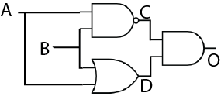

A | B | C | D | O
1 | 1
1 | 0
0 | 1
0 | 0

2) You encounter a problem on an exam with only answer choices:
- Option 1
- Option 1 or Option 2
- Option 2 or Option 3
You do not know what those options are, as the question has been omitted, but you know that only one answer (a, b, or c) is possible. Can you find that answer? Which of the 3 options was in fact correct? Explain your reasoning. (10 points)

Part III (two problems, each 10 points; total 20 points)

1) Let p and q be two propositions. The compound proposition p NAND q is false when both p and q are true, and true otherwise. It is denoted $p ↑q$ .Show that $p↑q⇔¬\left(p ∧q\right)$ (10 points)

2) Find a compound proposition logically equivalent to $p∨q$using only the logical operator $↑$. Show your work (10 points)

Appendix A: ASCII table

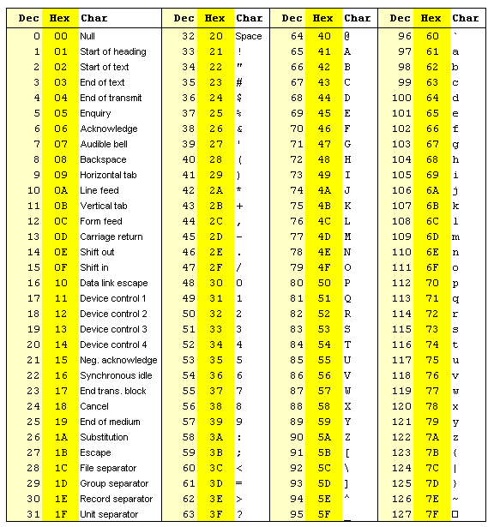

Appendix B: Binary to Hexadecimal

Base 10 | Base 2 | Base 16
0 | 0000 | 0
1 | 0001 | 1
2 | 0010 | 2
3 | 0011 | 3
4 | 0100 | 4
5 | 0101 | 5
6 | 0110 | 6
7 | 0111 | 7
8 | 1000 | 8
9 | 1001 | 9
10 | 1010 | A
11 | 1011 | B
12 | 1100 | C
13 | 1101 | D
14 | 1110 | E
15 | 1111 | F

