**ECS 17: Data, Logic, and Computing**

**Midterm 1**

**February 7, 2023**

***Notes:***

1. The midterm is open book, open notes.
2. You have 50 minutes, no more: I will strictly enforce this.
3. The midterm is graded over 70 points
4. You can answer directly on these sheets (preferred), or on loose paper.
5. Please write your name at the top right of each page you turn in!
6. Please, check your work! **Also, do show your work**

**Part I (6 questions, each 5 points; total 30 points)**

(These questions are multiple choices; in each case, find the most **plausible** answer)

1. ***How many songs could you store on 1GByte, if those songs were each 5 min long, sampled at 44.1 kHz, with each data point stored on 16 bits, in stereo (i.e., with two microphones)? Assume no compression.***
   1. About 10 songs
   2. About 20 songs
   3. About 40 songs
   4. About 60 songs
2. ***Let X be the number with the hexadecimal representation #89 and Y the number whose binary representation is (1111111)2; which of these numbers T (in hexadecimal form) satisfies X-T=Y?*** 
   1. #A
   2. #B
   3. #C
   4. #D
3. ***The hexadecimal equivalent of (1110010)2 is***
   1. #82
   2. #71
   3. #72
   4. #F2
4. ***The heart rate of a hummingbird can go as high as 1260 beats per minute. Which of these sampling rates would be appropriate to monitor this heart rate? (Circle all that applies)***
   * + 1. 1 Hz,
       2. 21 Hz,
       3. 42 Hz,
       4. 45 Hz.
5. ***If we sum the ASCII representations of the letters in the word A_ (where _ is unfortunately unknown), we get the hexadecimal #94. What is this letter currently represented with _ ?***
   * + 1. S
       2. T
       3. M
       4. L
6. ***You take a picture with a digital camera, and you know that this picture requires 64 Mbytes of storage (without compression). Assuming that each pixel is stored on 32 bits, how many pixels do the image contain?***
   1. 12 Mega pixels
   2. 16 Mega pixels
   3. 2 Mega pixels
   4. 32 Mega pixels

**Part II (two problems, each 10 points; total 20 points)**

1. Complete the logic table corresponding to the logic gate shown below. Which gate is it equivalent to? ***(10 points)***



|  |  |  |  |  |  |
| --- | --- | --- | --- | --- | --- |
| **A** | **B** | **C** | **D** | **E** | **O** |
| 1 | 1 |  |  |  |  |
| 1 | 0 |  |  |  |  |
| 0 | 1 |  |  |  |  |
| 0 | 0 |  |  |  |  |

2) Using only a logic table, show that $\overline{\overline{A+B}\left(\overline{B}+C\right)}=A+B$***(10 points)***

**Part III (two problems, each 10 points; total 20 points)**

1) A very special island is inhabited by knights, knaves, and spies. Knights always tell the truth, knaves always lie, and spies may tell the truth or lie. This island is special as its empress has set up the following rule: ``A knight can only marry a knave and a knave can only marry a knight". Clearly, a spy can only marry a spy. You meet two couples, let us call them Mr. and Mrs. Davis, and Mr. and Mrs. Dixon. Mr. Davis says, ``Mr. Dixon is a knight", Mrs. Davis says, ``This is true: Mr. Dixon is a knight", and Mrs. Dixon says, "I agree: my husband is a knight". What are each of the four people? Show your work (***10 points***)

2) You arrive in a country called Transylvania whose inhabitants are humans and vampires. Humans always tell the truth, while vampires always lie. However, both humans and vampires can be sane or insane. If an inhabitant is insane, she will believe that a truth statement is false, and a false statement is true. Sane inhabitants believe that truth statements are true and false statements are false. Thus, sane humans and insane vampires make only true statements, while insane humans and sane vampires make only false statements. You meet two inhabitants, Alex and Bill. You know that one of them is a human, and the other is a vampire. Alex tells you: “we are both insane”, while Bill tells you that “at least one of us is sane”. From this, can you find which one is the vampire? Show your work ***(10 points)***

Appendix A: ASCII table

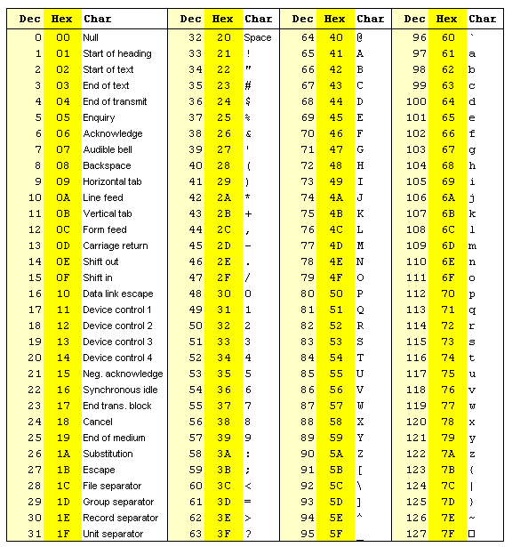

Appendix B: Binary to Hexadecimal

|  |  |  |
| --- | --- | --- |
| Base 10 | Base 2 | Base 16 |
| 0 | 0000 | 0 |
| 1 | 0001 | 1 |
| 2 | 0010 | 2 |
| 3 | 0011 | 3 |
| 4 | 0100 | 4 |
| 5 | 0101 | 5 |
| 6 | 0110 | 6 |
| 7 | 0111 | 7 |
| 8 | 1000 | 8 |
| 9 | 1001 | 9 |
| 10 | 1010 | A |
| 11 | 1011 | B |
| 12 | 1100 | C |
| 13 | 1101 | D |
| 14 | 1110 | E |
| 15 | 1111 | F |

