**ECS 17: Data, Logic, and Computing**

**Midterm 1**

**February 5, 2025**

***Notes:***

1. The midterm is open book, open notes.
2. You have 50 minutes, no more: I will strictly enforce this.
3. The midterm is graded over 70 points
4. You can answer directly on these sheets (preferred), or on loose paper.
5. Please write your name at the top right of each page you turn in!
6. Please, check your work! **Also, do show your work**

**Part I (6 questions, each 5 points; total 30 points)**

(These questions are multiple choices; in each case, find the most **plausible** answer)

1. ***The sum of the ASCII codes for the letters of a 3-letter word is #D8. Which of the following words could it be?***
   1. DOG
   2. CAT
   3. ZOO
   4. ANT
2. ***A biomedical engineer is designing a device to monitor human heart activity. The device must accurately capture an ECG signal containing frequency components up to 150 Hz. However, to account for potential noise and ensure proper filtering, the engineer decides to include a safety margin of 20% above the maximum signal frequency. Which of these sampling frequencies could the engineer use (circle all that apply)?*** 
   1. 150 Hz
   2. 180 Hz
   3. 300 Hz
   4. 360 Hz
   5. 380 Hz
3. ***Let x be a hexadecimal digit (i.e. a number in {0, 1, 2, 3, 4, 5, 6, 7, 8, 9, A, B, C, D, E, F}. We know that #x0 + #1x = #Ax (where # means that the numbers are given in hexadecimal format; for example, if x = 1, #x0 = #10 = (16)10). Solve for x:***
   1. 7
   2. 8
   3. 9
   4. A
4. ***On a quiz for ECS17, you are asked to solve a simple math problem. Unfortunately, the printout of the question failed and instead of writing the characters, it wrote the ASCII code for those characters:***

***#23 #33 #41 #20 #2B #20 #23 #32 # 46 #20 #3D***

***What is the result of this problem (in decimal format)?***

* + - 1. 68,
      2. 70,
      3. 104,
      4. 105.

1. ***A marine biologist is conducting two simultaneous studies on a fish species:***

* ***Recording their tail movement which occurs at 12 Hz***
* ***Recording their gill movement which occurs at 15 Hz***

***If the biologist wants to use a single recording system to capture both movements accurately, what sampling rate could they use? (circle all that are correct)?***

* + - 1. 12 Hz,
      2. 15 Hz,
      3. 24 Hz,
      4. 30 Hz,
      5. 32 Hz.

1. ***A home security system has three sensors:***

* ***A window sensor (W): outputs 1 if the window is open***
* ***A motion detector (M): outputs 1 if motion is detected***
* ***A door sensor (D): outputs 1 if the door is open***

***An alarm connected to those sensors should trigger EITHER when the window is open AND motion is detected, OR if the door is open, BUT NOT when both those 2 conditions are met (i.e. the OR is exclusive). Which Boolean expression correctly represents when the alarm should trigger?***

* 1. ,
  2. ,
  3. ,
  4. .

**Part II (One problem with 2 questions, each 10 points; total 20 points)**

Consider the Boolean expression $A∙B+B∙C∙(B+C)$

1. Draw the logic circuit using basic gates
2. Build its truth table

**Part III (two problems, each 10 points; total 20 points)**

1) You arrive on an island inhabited by **Knights (who always tell the truth)** and **Knaves (who always lie)**. You meet **three islanders**: **Alex, Blake, and Casey**. You know that **at least one of them is a Knight and at least one is a Knave**, but you do not know how many of each there are.

You ask each of them, **“How many of you are Knights?”**

* **Alex** says, *“At least one of us is a Knave.”*
* **Blake** says, *“Alex would say that exactly one of us is a Knight.”*
* **Casey** surprisingly says, “*I really like peanut butter*”.

Can you determine who are the Knights and who are the Knaves? Does Casey really like peanut butter? Explain your reasoning. (***10 points***)

2) On an island, there are three tribes:

* Day-Tribers, who always tell the truth during the day and lie at night.
* Night-Tribers, who always lie during the day and tell the truth at night.
* Spy-Tribers, who may lie or tell the truth at any time.

You arrive on the island and meet three people, Alice and Bob, and Cathy. You know that one is a day-Triber, one is a night-Triber, and one is a spy-Triber.

* Alice says: *“Bob is a night-Triber.”*
* Bob says: *“Cathy is the spy-Triber.”*
* Cathy says: *“Alice is the day-Triber and it is day.”*

Can you determine whether it is currently day or night, and which tribe(s) Alice, Bob and Cathy belong to? Explain your reasoning. ***(10 points)***

Appendix A: ASCII table

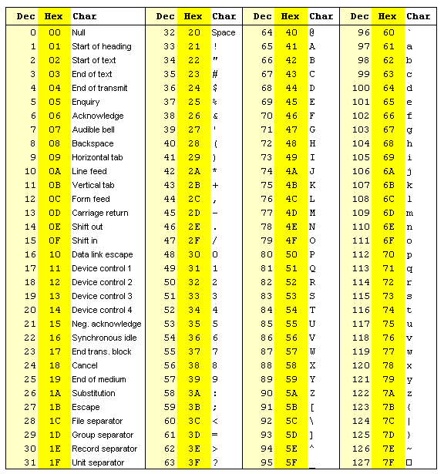

Appendix B: Decimal / Binary / Hexadecimal

|  |  |  |
| --- | --- | --- |
| Base 10 | Base 2 | Base 16 |
| 0 | 0000 | 0 |
| 1 | 0001 | 1 |
| 2 | 0010 | 2 |
| 3 | 0011 | 3 |
| 4 | 0100 | 4 |
| 5 | 0101 | 5 |
| 6 | 0110 | 6 |
| 7 | 0111 | 7 |
| 8 | 1000 | 8 |
| 9 | 1001 | 9 |
| 10 | 1010 | A |
| 11 | 1011 | B |
| 12 | 1100 | C |
| 13 | 1101 | D |
| 14 | 1110 | E |
| 15 | 1111 | F |

