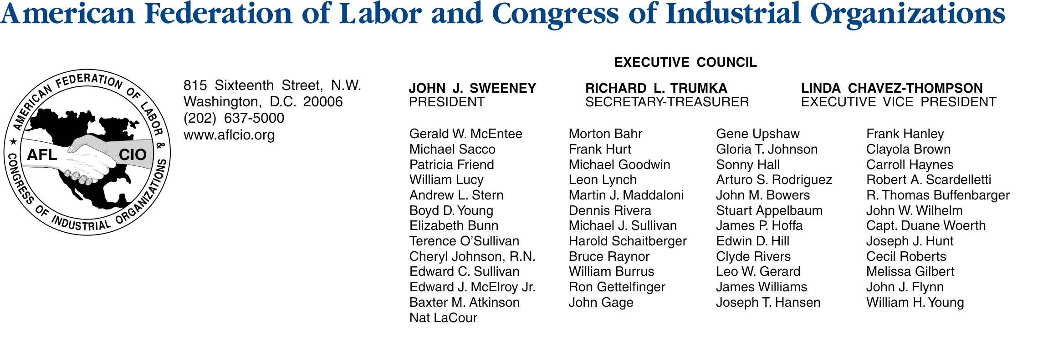

September 20, 2004

Honorable Orrin G. Hatch, Chairman
Senate Committee on the Judiciary
224 Dirksen Senate Office Building
Washington, D.C. 20510

Dear Chairman Hatch:

The AFL-CIO urges the Senate Judiciary Committee to oppose the substitute bill to S. 1635, sponsored by Senator Saxby Chambliss, when it is considered in committee. As you may know, the AFL-CIO has supported placing needed restrictions on the L-1 intracompany visa program. The substitute bill, however, fails to impose enough labor market protections on the L-1 program, and would create a new permanent exemption from the statutory cap on the H-1B program for foreign students receiving a masters or Ph.D degree in the U.S.

We are concerned that the proposed H-1b exemption is completely disconnected from U.S. labor market conditions, particularly in information technology (IT), which continues to be the single largest occupational category of H-1b visas. Overall, the U.S. technology employment market shrank 18.8% from March 2001 to April 2004; unemployment in all professional occupations has soared (see attached chart); and offshoring of IT and other jobs continues to climb.

The National Science Foundation reports that there were 145,112 foreign graduate students enrolled in postgraduate science and engineering programs alone in U.S. in 2002, and it is unclear how many of these students or those in other fields might take advantage of the new exemption. The substitute bill also fails to correct key problems long-identified by the U.S. General Accounting Office (GAO) and DOL’s Inspector General with the H-1b program, such as inadequate documentation of the prevailing wage rate actually paid workers, the limited authority of both the Employment & Training Administration (ETA) to review the labor applications submitted by H-1b employers, or the Wage & Hour Division (WHD) to investigate violations of the program. Despite governmental studies identifying these and other problems in the program, the substitute does not address those issues.

While the substitute bill prohibits subcontracting L-1 visa holders, a much-needed reform, it fails to enact other key labor protections, such as a cap on the program or a prevailing wage requirement. Given the increased use of the L-1 program in recent years, and the frequent reports of the program being misused, we believe more reforms are necessary to that program.

For these reasons, we urge you to oppose the Chambliss substitute to S. 1635 when it is considered in committee.

Sincerely,

William Samuel, Director
DEPARTMENT OF LEGISLATION
Attachment
c: All members of the Senate Committee on Judiciary

