17 September 2004

The Honorable Orrin Hatch
Chair, Senate Judiciary Committee
104 Hart Building
United States Senate
Washington, DC 20510

Re: S. 1635, the L-1 (Intra-Company Transferee) Visa Reform Act

Dear Senator Hatch:

While we support continuing efforts by Senator Chambliss and others on the Judiciary Committee to advance carefully crafted legislation that will provide a much-needed remedy for recent abuses of the L-1 (Intra-Company Transferee) Visa program, IEEE-USA opposes the addition of provisions that would raise the H-1B (Specialty Occupation) visa ceiling by creating an exemption for foreign nationals who earn Masters and PhD degrees at U.S. colleges and universities. Such a proposal is unwarranted, unnecessary and likely to have unintended consequences at a time when unemployment among many high tech professionals, including electrical, electronics and computer hardware engineers, remains at historically high levels.

Based on a recent survey of hiring managers, the Information Technology Association of America has concluded that “demand for IT workers continues to drop” and that IT and non-IT companies will fill 270,000 fewer jobs this year than they did in 2003. Most of the jobs that are being created are in low-skilled service occupations, not in highly skilled positions like the ones that the H-1B program is intended to help fill. Until such time as there is a marked drop in the unemployment rate among high tech professionals – it reached an unprecedented 7.0% for computer hardware engineers and 6.2% for electrical and electronics engineers last year – there’s no need to raise the H-1B visa cap, either directly or indirectly, by creating a special exemption for foreign graduate students.

We agree that it is contrary to the long-term competitiveness of the United States to train the world’s best and brightest in cutting edge science and engineering disciplines and then send them home with taxpayer subsidized knowledge and skill to compete against U.S. companies. But giving foreign graduates of U.S. educational programs a temporary work visa doesn’t resolve this problem, it just postpones it while they acquire even more valuable experience and business contacts. A better approach would be to improve the nation’s permanent immigration system and put talented students on a fast track to U.S. citizenship, instead of consigning them to second-class status on a temporary work visa.

In addition, current law provides for a better transitional alternative than an H-1B visa for foreign graduates of U.S. colleges and universities. Administrative regulations governing employment authorizations for temporary visitors allow foreign nationals on F (Foreign Student) and J (Exchange Visitor) visas to obtain practical work experience in their chosen fields upon completion of their degree requirements. It’s much easier and quicker for foreign students to obtain the necessary authorization for optional practical training than it is to secure an H-1B visa. Optional practical training also provides much greater flexibility in the choice of employers than an H-1B visa. Once their application has been approved, foreign graduates of U.S. schools can work wherever and for whomever they want, as long as the employment is related to their field of study. H-1B visa holders, on the other hand, can only work for sponsoring employers.

2

The committee should also consider the possible unintended consequences of creating a special visa cap exemption for foreign graduate students. By making U.S. educational institutions more attractive to foreign science and engineering students, the visa exemption may actually result in declining enrollments for U.S. students and thus increase our dependence on non-citizens for the for the technical talent needed to maintain our leadership in an increasingly competitive global economy.

For all of the above reasons, we urge you to oppose efforts to amend the L-1 Intra-Company Transferee Visa Reform Act (S. 1635) to include unwarranted and unnecessary H-1B provisions in committee and on the floor of the United States Senate.

Sincerely,
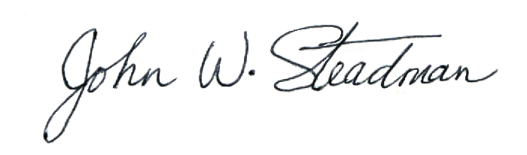
John W. Steadman, P.E., Ph.D.
IEEE-USA President

IEEE-USA was established in 1973 to advance the careers and public policy interests of the more than 225,000 electrical, electronics, computer and software engineers who are U.S. members of the IEEE, the world’s largest technical professional society.

